Camelot and Avalon Projects:
Cases of Amplifying Disinformation
Jean-Pierre Petit
http://www.jp-petit.org
The internet is the last remaining bastion of freedom for the individual.
We now know that, across the globe, the official media are no longer trustworthy. In earlier times, the press was thought of as the “4th power”, a means of expression capable of counterbalancing political powers. Such has been the case in the past, and such remains the case today. Regrettably often too late at night, some networks occasionally broadcast programs that shed light on buried archives or highlight the results of courageous and rigorous investigations. Thanks to such programs, the viewers can discover never previously unearthed historical facts, or facts that were once known, but have since been forgotten more or less consciously. The example that comes to my mind is the case of Japan’s experiments on bacteriological war tools conducted in 1931, with the complicity of the imperial family. Excellent TV shows are occasionally produced indeed, and thus one cannot reject the “official media” as a whole. However, particular topics are typically avoided altogether, or, if addressed at all, they are presented superficially, with no effort to investigate in depth. The UFO topic for example, is typically covered with undertones of mockery, with no regard for the fact that the issue:
- is grounded in real facts
- has been the subject of sound scientific work, such as, among others, investigating the possibility of hypersonic flights without shock waves nor turbulence, i.e. in a complete silence
Such endeavors have been the subject of PhD theses and of numerous presentations at international symposia on MHD, and more recently at the AIAA symposium in Bremen, (19 pages, 17 Mos)
http://www.jp-petit.org/science/mhd/breme_2009.pdf
Experimental results will be presented at upcoming international scientific symposia, none of which are ufology conferences.
One such serious, scientifically-minded symposium will take place in Strasbourg, France on October 16 and 17, 2010.
The public is ignorant of the fact that a bridge between the UFO issue and science was established many years ago, and the media continues to obscure this fact by putting individuals on display who lack a solid scientific background, and who are free to discuss their fantastic claims on TV .
The viewers of such broadcasts are treated to a wide range of varied psychopathic deviances and are exposed to writers exploiting what they perceive to be a gold mine. It is true that the UFO file contains disconcerting and puzzling aspects that cannot remain unsaid; however, as a scientist, I am of the opinion that priority should be given to a hard-nose, “nuts and bolts" scientific approach. For over thirty long years, the data has shown that this is possible, with no need to rely on notions as speculative as that of antigravity.
Among this plethora of writers and colorful contributors, one can find true disinformation pros, dedicated to spreading so-called information, entirely devoid of factual basis. One of these authors is David Icke, the well-known author of the book
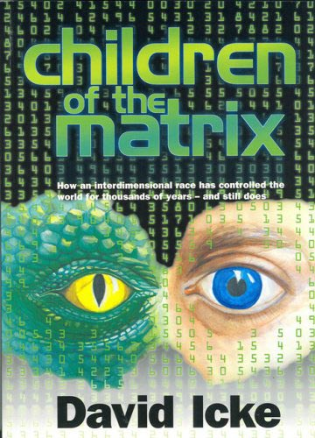

and many others of the same mold. David Icke crisscrosses the globe, going from conference to conference, in an effort to spread the delirious theory that Earth, from time immemorial, has been colonized by an extraterrestrial breed of reptilians, which count among them Bill Clinton, his wife, George Bush and many other public figures. He makes this assertion without advancing the shadow of a beginning of any evidence. The term

Amplifying Disinformation

seems well suited to describe this modus operandi. No technique is more effective than bundling an important topic with….fiction.
This plot has been the subject of a television series, “V”, watched by millions of people.
David Icke identifies a number of famous political figures as “reptilians”.
We live in an era in which deep confusion prevails and the attitude of the public throughout the world can be summed up by drawing a continuous line, with a sliding gage. At one end of the continuum lies a soundly asleep citizen, confident in the idea that there is no need to worry about anything, that things are unfolding “normally” in the world as a whole, and that alarming hypotheses, regardless of whether they pertain to fears of war, ecological or monetary disasters, are nothing but rumors about which one should not fret.
At the other end of the continuum is a citizen who ingests every single alarming bit of information as forecasting disaster, in whatever domain, and who shelters himself in a self-constructed personal bunker.
Where should one place the gage?
We do not have the answer to this question. We simply want to remind the reader of a page of history that should prompt reflection: Namely, the return to London of Arthur Neville Chamberlain after his meeting with Adolf Hitler in Munich in 1938, at a time when all the nations of the world were beginning to worry about the possibility of an impending war.
Visualize the enthused Englishman brandishing a piece of paper baring the signature of the Fuhrer while exclaiming “Peace is saved”. For those who ignore this historical fact, let’s sum it up in a few words. In 1938, Hitler had annexed Austria. European countries were concerned about the appetite exhibited by the leader of a Germany which, by then, had become Nazi. The Sudetes were the subject of his latest demands, a region that served as a buffer between Germany and Czechoslovakia – incidentally a country was not invited to the conference.



The region of the Sudetes is located in Czechoslovakia as it was delineated at the time, near the border with Germany. The population of this region included groups from German descent, which, after the annexation, adhered en masse to the Nazi ideology. After WWII, the Czech population obtained their expulsion in lieu of retribution for damage of war.

To annex the Sudetes, Hitler sought the backing of the great powers, among which were England and France, by assuring them that this would mark the end of his territorial ambitions.
When he received the green light, Hitler became convinced of the weakness of the democratic nations and launched Germany into a megalomaniac enterprise that ended in a disaster for all the countries of the world, including his.
History shows that many historical cataclysms have their roots in the most blind and the most stupid of behaviors.



Arthur Neville Chamberlain in 1938, at Munich Betrayal, then brandishing the signed document upon his return: Peace is saved !

At this point, I want to quickly add that the choice of this historical anecdote is not directly correlated to any current situation, and that I am not implying such connection. I use this anecdote only to remind ourselves that the history of the world includes periods that resulted in total chaos, even though nobody at the time had considered it a real possibility.
In today’s troubled times, it is important, even vital, to ask ourselves questions, to ask ourselves every possible question. However, one needs access to information, to analyze the data, assuming that the information is reliable. If not completely reliable, the information should at the very least be based on facts or on a sound argument.
Based on this premise, David Icke’s assertions are entirely devoid of substance. They represent the confabulations of a histrionic pathological liar. Nevertheless, these lies are met with considerable public acclaim via two websites, namely
http://projectcamelotportal.com http://projectavalon.net
These two projects were initiated by Bill Ryan, an ex-corporate psychologist (Hewlett Packard, British Aerospace Company, and so on) and by Kerry Cassidy, sociologist by training. The assertions that have come out of these websites represent the most farfetched mishmash imaginable, that craftily bundles real issues with baseless mumbo jumbo.
Here is the copy of the home page of project Avalon run by Bill Ryan, dated July 19, 2010 :


Here is what can be found on the same page :
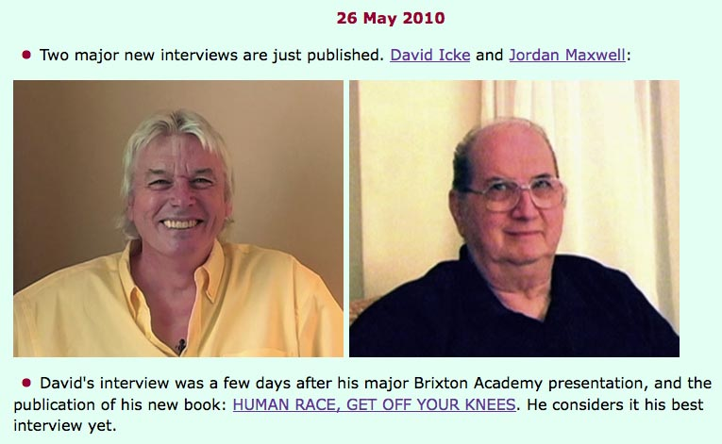
Better yet, an interview of a 31 year-old man by the name of Aaron Mac Collum was featured on the website of project Camelot [link]. This character introduces himself as an ex-member of the military (Coast Guard) and goes on with rants of pathological lies.
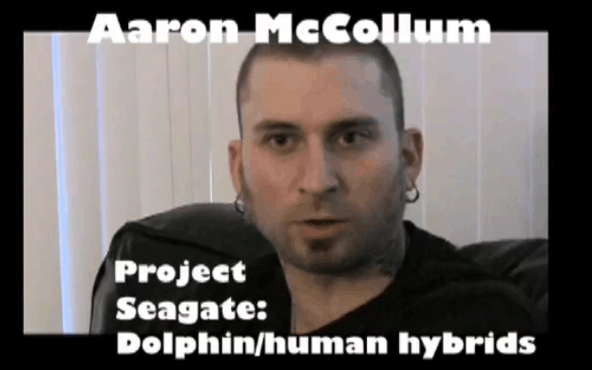
http://projectcamelotproductions.com/interviews/aaron_mccollumII/aaron_mccollumII.html
According to him, the present gathering of ships of various nationalities near Yemen is connected to the discovery of a « space-time gate,” which he calls “Seagate”, the presence of which translates in a “powerful magnetic field”. He adds that the attacks by pirates in the region were entirely simulated to preclude anyone from intruding there.
These assertions, obligingly recorded and broadcast on the Project Camelot website are substantiated by nothing. One can seriously question whether such discourse does not represent a campaign of disinformation and manipulation of the international public opinion designed to divert its attention from other burning issues: the risk of conflict between USA/Israel against Iran, which could in turn precipitate WWIII.
In this article, I encourage people to reconsider their opinion of these two sites, of these two projects, as well as of the statements of Bill Ryan, Kerry Kennedy and beyond them, of the statements of their entire entourage, starting with David Icke. Don’t be misled by lies…. Don’t be manipulated by dubious characters.


Act like us !

