Alternative to inflation. Variable speed of light cosmological model
with Lorentz and fine structure constant invariance maintained

J.P.Petit , G.D’Agostini

___________________________________________________________________________________________________
Keywords : Lorentz invariance, variable speed of light, variable constants regime, radiative era, Compton length, inflation, generalized gauge phenomenon
___________________________________________________________________________________________________

Abstract: Within the framework of the Janus cosmological model, we investigate an alternative to the inflationary scenario based on the existence of an early phase preceding decoupling and the radiation-dominated era. During this phase, the six fundamental physical constants—along with the space and time gauge factors associated with the model's two sheets—evolve in a correlated manner through a generalized gauge process. This evolution is constrained by the invariance of the fundamental equations of physics, the Einstein constant appearing in the coupled field equations, and the fine-structure constant, while Lorentz invariance is preserved in both sheets.

We show that this generalized gauge process is consistent with the conservation of various forms of energy and implies that characteristic physical lengths evolve in proportion to the corresponding spatial scale factors—notably the cosmological horizons. Since radiation itself acts as a source of the gravitational field, Jeans instability can occur during the radiation-dominated era. Due to the intrinsic asymmetry between the two sheets of the Janus model, their cosmological horizons evolve on vastly different scales. Consequently, fluctuations developing in the negative-mass sector can affect the positive-mass sector during its subsequent matter-dominated era.

This mechanism provides a possible alternative origin for the primordial fluctuations observed in the cosmic microwave background (CMB), without invoking an inflationary phase. A quantitative test of this scenario requires determining the spectrum of non-linear fluctuations generated in the negative-mass sector, establishing their transfer to the positive-mass sector, and then comparing the resulting spectrum with CMB observations.

This asymmetry also leads to a higher speed of light in the negative-mass sector. Should a material object transition to this sector by inverting the sign of its mass, this property would open up the possibility of significantly reducing interstellar travel times as measured in the positive sector. In this context, we outline a geometric mechanism for transition between the two sheets, based on a localized concentration of energy around the object in question.

___________________________________________________________________________________________________

1 – Introduction.

It is no exaggeration to say today that cosmology and astrophysics are facing an unprecedented crisis. For decades, efforts were made to salvage the Standard Model by augmenting it with two new components: dark matter and dark energy. By reintroducing the cosmological constant Λ into the general relativity equation, equating it to a constant negative energy density, the model was able to account for a constant acceleration of expansion, implying exponential growth over time. However, in 2025, initial results reported by the DESI collaboration [1] suggest that this acceleration was greater in the past—a topic that remains a subject of debate within the scientific community. This represents a phenomenon that the Standard Model cannot explain. In contrast, the Janus Cosmological Model (JCM), based on a system of coupled field equations, has predicted this cosmic dynamic since 2014 [2], relying on a twin-universe model characterized by a strong asymmetry between its two components.

( 1) $R_{μν} - \frac{1}{2} R g_{μν} = χ \left( T_{μν} + {\sqrt{ \frac{\overline{g}}{g}} K}_{μν}\right)$

( 2) ${\overline{R}}_{μν} - \frac{1}{2} \overline{R} {\overline{g}}_{μν} = - χ \left({\overline{T}}_{μν} + {\sqrt{ \frac{g}{\overline{g}}} \overline{K}}_{μν}\right)$

Presented below is the expansion law, the exact solution to the system of JCM field equations [2].
( 3) $a(u) = α^{2} cosh^{2}u$

( 4) $t(u) = α^{2} \left( 1 + \frac{sh2u}{2} + u \right)$

Here is the corresponding curve:

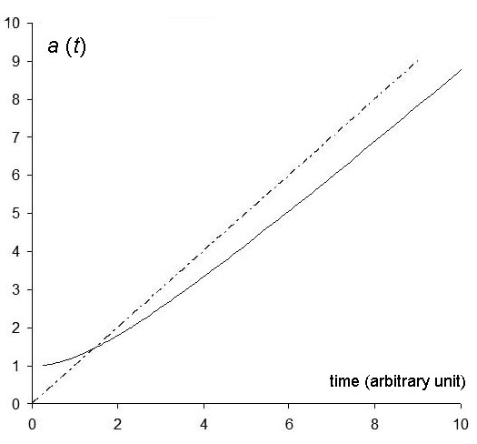

Fig.1 : Janus expansion law, in the form of an exact solution [2].

It should be noted that this solution, in which the negative energy density decreases over time, yields an expansion that gradually approaches a linear time dependence, whereas in the ΛCDM model—where dark energy density is invariant—the expansion is exponential.

Figure 2 shows the evolution of the acceleration:

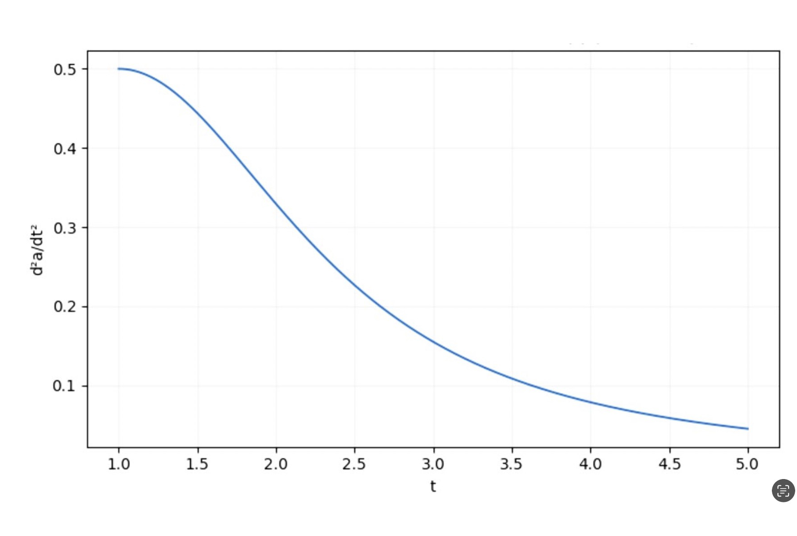
Fig.2 : Evolution of acceleration [2].

It is well known that, in the late 1980s, the discovery of the extreme homogeneity of the early universe—specifically the CMB—immediately posed a major problem. The diagram below illustrates this.

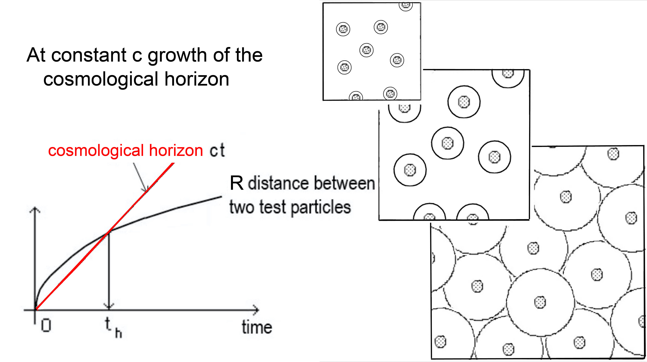

Fig.3 : The problem of the homogeneity of the early universe.

For more than three decades, the inflation model has served as the scientific community's answer to this problem, forming part of the standard cosmological scenario. Between 10⁻³⁶ and 10⁻³² seconds, the universe, thought to be populated by inflatons, is believed to have undergone an expansion by a factor of 10²⁶. At the end of this phase, these inflatons would have given rise to the menagerie of particles we know today. Unfortunately, there is no complete description of this entire scenario.

An alternative solution would be to consider that the speed of light had a higher value in the past, in order to account for such homogeneity. However, such variability in this fundamental physical parameter immediately breaks the invariance of the fine-structure constant, which is then no longer guaranteed.
( 5) $α = \frac{e^{2}}{4 π ε_{0} ℏ c }$

The entire field of atomic physics then immediately suffers an impact that is difficult to manage.

There is another objection, of a purely geometric nature. Special relativity imposes local invariance under the Lorentz group. This is a subgroup of the Poincaré group, the isometry group of Minkowski space. Relativistic length is given by the Lorentz metric:

( 6) $ds^{2} = c^{2}dt^{2}- dr^{2} - r^{2}\left( dθ^{2}+ sin^{2}θ dφ^{2} \right)$

Its invariance is thus immediately broken if one allows c to vary. To draw a comparison: imagine that one of the dimensions of 3D Euclidean space were affected by a gauge variation. It would then no longer be possible to perform a rotation within it. The rotation group would "cease to function." A variation in c has a similar impact in 4D, with the Lorentz group "ceasing to function." In such an affected spacetime, it becomes impossible to perform those 4D rotations that constitute the very source of special relativity.

As early as 1988 [3,4], the idea was proposed of varying a certain set of constants, but all of them simultaneously. There are six physical constants:

- Speed of light : c
- Planck's constant: h
- The constant of Gravitation: G
- Unit electrical charge: e
- Magnetic permeability of free space: $μ_{0}$
- The unit masses m

The dielectric constant of the vacuum $ε_{0}$ can be derived from the relation:

( 7) $c = \frac{1}{\sqrt{ ε_{0}μ_{0}}}$

Consequently, if simultaneous variations of $μ_{0}$ are introduced, the quantity $ε_{0}$must then be treated as an absolute constant (an arbitrary choice, given that one could just as well take $ε_{0}$ as variable and $μ_{0}$ as constant).

But that is not enough. Lorentz invariance must still be maintained. This can only be achieved by introducing a gauge phenomenon that affects space and time variables alike. Let us now look for guiding ideas that would allow us to envisage the early universe undergoing a phase of evolution characterized by "variable constants and space-time gauge factors."

2 – The principles behind the construction of such a model.

A first idea, in the search for a generalized gauge phenomenon, is to construct it in such a way that all the equations of physics remain invariant—namely, the field equation and the equations of quantum mechanics, electromagnetism, and fluid mechanics.

This framework leads us to consider the state of the universe in the distant past. Directly usable information, carried by light, only becomes available after decoupling, at t = 380,000 years. For the period prior to this, we can only make inferences based on what we observe today. In 1920, the discovery of cosmic expansion by E. Hubble and the solutions provided by A. Friedmann compelled scientists to consider—by tracing time backward—that the universe had once been much hotter and denser. The model showed that photon wavelengths evolved in step with the cosmic scale factor, a. Observations had demonstrated that high-energy photons could give rise to matter-antimatter pairs. This scenario was vividly described by S. Weinberg in his famous book “The First Three Minutes” [5]; he depicts the universe as filled with "all sorts of radiation"—using the plural to indicate that massive components (both matter and antimatter) were moving with thermal agitation speeds approaching the speed of light.

It was here that the standard cosmological model found an observational anchor, aligning with the discovery of cosmic expansion. The universe—teeming with high-energy photons—was constantly giving rise to matter-antimatter pairs; these particles, bearing opposite electric charges and thus attracting one another, would quickly annihilate each other a short distance away, transforming back into radiation. Consequently, as the photons lost energy simply due to the expansion, they were no longer able to compensate for the losses caused by annihilation. This explains the existence of the 2.7 K background radiation, serendipitously detected by Penzias and Wilson in 1967. Detecting this "ash" from cosmic expansion reinforced the hypothesis of a primordial explosion, while also making it possible to trace events back
to $t = {10}^{-2}$ second.

It is worth noting in passing that this advance in knowledge—this ability to look further back into the past—brought with it a new and significant problem: why did one particle in a billion remain? Why was the annihilation of this primordial matter and antimatter not total? It is a question that, to this day, still awaits a satisfactory answer. Setting this new problem aside, a question then arises:

- And before ${t = 10}^{-2}$ second ?

On what factual evidence can a description of cosmic history in an earlier era be based? Scientists envisioned that experiments conducted in their particle accelerators would enable them to propose answers to this question. These experimental devices were intended to recreate the state of the universe as it existed in earlier epochs. The first success was, of course, the ability to create antimatter in the laboratory. However, the progressive increase in energy levels now faces a new problem: the particles that this escalation was expected to produce, superparticles, categorically refuse to appear. The impasse is so glaring that those proposing to invest vast sums in expanding the LHC find themselves unable to answer the question:

- And what do you hope to find with this device?

In any case, what is missing from these experiments is the density parameter, which these setups cannot reproduce. After initially inducing proton collisions, the approach is now being extended to collisions involving heavy ions, specifically lead or gold. However, we are still far from the mark. A rarefied or moderately dense medium does not, a priori, behave like a hyperdense one. We have no reliable model to offer for this state, found at the core of hyperdense neutron stars and described as a "soup of quarks and gluons."

The calculation then shows that the average distance separating the hadrons approaches their Compton wavelength:
( 8) $λ_{C} = \frac{ ℏ}{m c }$

The standard explanation for how density can increase is that hadrons can fragment into smaller components—specifically, the appearance of free quarks. Indeed, this general concept applies as one delves deeper into a neutron star. After the constituent atoms have disintegrated into a plasma of protons and electrons, and the distance between these components falls below the electron Compton wavelength, the electrons vanish by combining with protons to form neutrons. At even greater depths, it is the mesons that, in turn, disappear.

Is there, then, a mechanism that could serve as an alternative to this hierarchical fragmentation? To illustrate this idea, we employ a 2D toy model. The masses represent local concentrations of curvature. Let us imagine a closed universe containing eight masses. The resulting shape of such a universe is a truncated cube. The total curvature of this cube is 4π. The eight truncated vertices of the cube are spherical octants, each concentrating a curvature of π/2. These elements are joined by curvature-free surfaces consisting of quarter-cylinders and flat sections; the latter represent the "void" separating the eight masses. The expansion of this universe—which possesses the topology of an S² sphere—results from the stretching of the flat sections. This reflects the standard model, in which photons bear the cost of expansion, with their wavelengths tracking the pace of cosmic stretching.

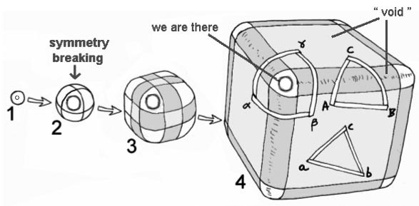

Fig.4 : A toy model to schematize evolution.

From this perspective, masses can be likened to "frozen space”.

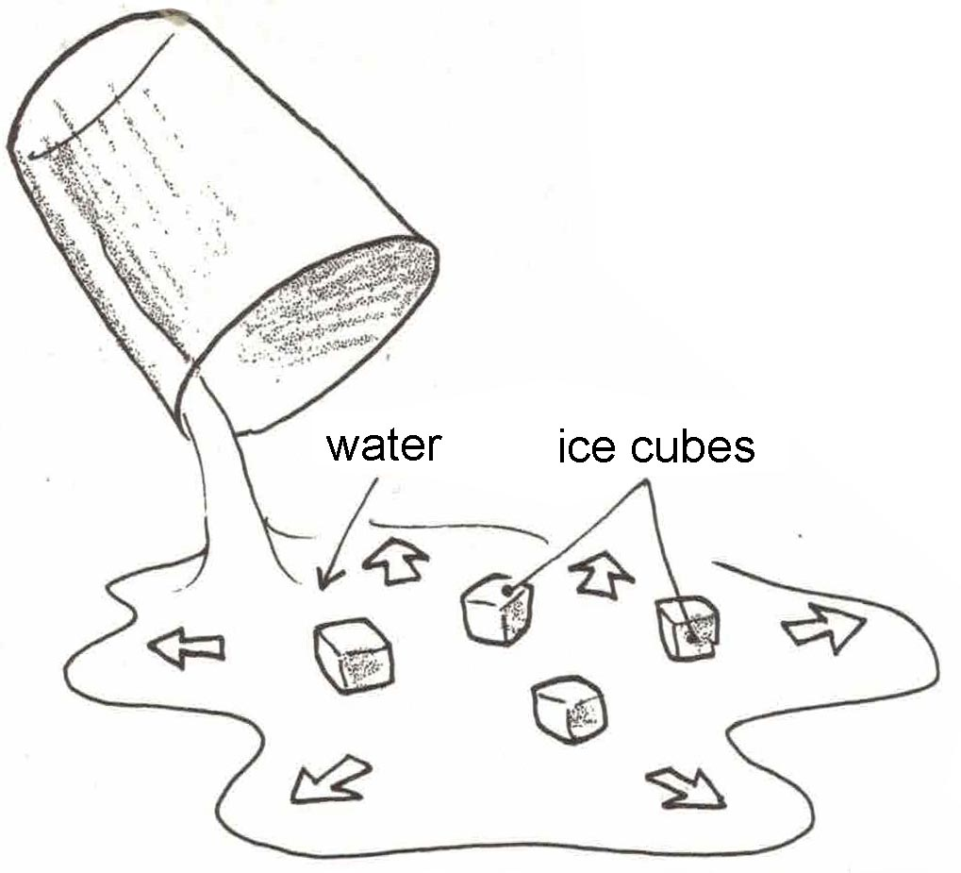

Fig.5 : Didactic model in which the masses are represented by ice cubes.

Tracing the history of this universe back, we observe in Figure 4.3 that the eight sphere-octants come into contact with one another. This corresponds to the moment when the masses make contact, when the distance separating them becomes comparable to their Compton wavelength. Instead of seeing these "masses" fragment into smaller components, we can envision a transition to a regime with variable constants, where the Compton wavelength varies in proportion to the spatial scale factor a:
( 9) $λ_{C} = \frac{ ℏ}{m c } \sim a$

We thus have here an initial idea suggesting a possible link between various constants, specifically Planck's constant, mass, and the speed of light, through what we will term a "gauge link." Let us now see what can be derived from this invariance of the equations of physics.

3 – Invariance of the field equation.

Let us begin by considering Einstein’s field equation in the absence of a cosmological constant:

( 10) $R_{μν} - \frac{1}{2} R g_{μν}= χ T_{μν}$

The Einstein constant will be given the form:

( 11) $χ = - \frac{8 π G }{c^{2}}$

This search for a generalized gauge relationship is analogous to the dimensional analysis used by physicists, in which elements such as mass, electric charge, and energy are replaced by dimensionless quantities. Here, we apply the same approach to the variables of time and space.

For space, we set: $r = \hat{a} a_{0} ζ$ , $a_{0}$ is the standard scale factor. Let $t_{cr}$. be the moment when evolution driven by gauge fluctuations takes over. At this moment, all quantities have the following values:

( 12) $\left( c_{0} , h_{0} , G_{0} , m_{0} , e_{0},μ_{0-act} , r_{0} ,{ t}_{0} , v_{0} \right)$

We thus have a snapshot of the state of the universe, with the values ​​of the various constants.

We can extend this concept back in time by envisioning a different evolutionary mechanism—a generalized gauge process in which all these quantities vary in tandem. While this is a rather unusual scenario to picture, we must first bear in mind that when this mechanism takes over, we are in the era prior to decoupling. Consequently, the universe has effectively returned to a state of homogeneity and isotropy. Let us illustrate this scenario with a simple analogy. Imagine a viewer watching a film—played in reverse—that depicts the history of a universe bounded by a circular edge. On the screen, they first see galaxies disintegrating and stars vanishing. At the moment of decoupling, the interior of the disk appears homogeneous. However, the story then unfolds differently before their eyes as the bounding circle begins to shrink. Inside the circle, one can discern a regular distribution of points representing particles; these appear and disappear at an accelerating rate, acquiring increasingly high random agitation velocities. Simultaneously, the hue within the circle shifts in color and grows brighter.

In short, we are witnessing a scene where "something is happening", yet where the universe nonetheless retains a high degree of homogeneity.

All these quantities will then be modulated and weighted by functions:

( 13) $\left( \hat{c} , \hat{h} , \hat{G} , \hat{m} , \hat{e},{\hat{μ}}_{o} ,\hat{a} , \hat{t} , \hat{v} \right)$

These functions all equal 1 at the time $t_{cr}$ of the evolutionary transition. Looking further back into the past, some will be increasing while others are decreasing. What we seek is for their variations to leave all the equations of physics invariant. We can express this by writing that, in this "variable-constant" phase:

( 14) $c = \hat{c} c_{0}$

( 15) $h = \hat{h} h_{0}$

( 16) $G = \hat{G} G_{0}$

( 17) $m = \hat{m} m_{0}$

( 18) $e = \hat{e} e_{0}$

( 19) $μ_{0} = {\hat{μ}}_{0} μ_{0-act}$

( 20) $a = \hat{a} a_{0}$

( 21) $t = \hat{t} t_{0}$

( 22) $v = \hat{v} v_{0}$

Let us apply this to the field equation (without a cosmological constant):

( 23) $R_{μν} - \frac{1}{2} R g_{μν} = χ T_{μν}$

The Ricci tensor $R_{μν}$ will evolve according to:

( 24) $R_{(0) μν} ⟶ {\hat{R}}_{μν} R_{(0) μν}$

However, we know that the components of the Ricci tensor have the dimension of the inverse of a length. Its gauge variation will therefore result from the variation of the spatial scale factor a, and we can write:
( 25) ${\hat{R}}_{μν} = \frac{1}{{\hat{a}}^{2}}$

A physicist will have their own way of expressing this in writing, more directly:

( 26) $R_{μν }\sim \frac{1}{a^{2}}$

The line element is :

( 27) ${ds}^{2}= g_{μν} dx^{μ} dx^{ν}$

In both members, we find the square of a length. This means that the quantities, which are simple numbers, are not altered by the gauge variation, a fact we can write as follows:

( 28) ${\hat{g}}_{μν}= 1$

The Ricci scalar R also has the dimension of the inverse of the square of a length.

We shall assume that Einstein’s constant $χ$, taken not in its "modern" form but in its "historical" form, behaves as an absolute constant.

( 29) $χ = - \frac{8 π G}{c^{2}} = Cst$

This corresponds, within the gauge variations under consideration, to:

(30) $\hat{G} = {\hat{c}}^{2}$
Or :
( 31) $\boxed{ G \sim c^{2}}$

We will refer to this type of relationship as a "gauge link." In these joint gauge variations:

The gravitational constant varies as the square of the speed of light.

With this choice of formulation for the Einstein constant $χ$, the terms of the source tensor have the dimension of a mass density $ρ$, which undergoes gauge variation through the gauge variations of the mass $\hat{m}$ and the spatial scale factor $\hat{a}$. This results in:

( 32) $ρ = \hat{ρ} ρ_{0} = \frac{\hat{m}}{{\hat{a}}^{3}} ρ_{0}$

When we incorporate all this into the field equation, we obtain:@
( 33) $\frac{1}{{\hat{a}}^{2}} R_{(0)-μν} = χ \frac{\hat{m}}{{\hat{a}}^{3}} T_{(0)-μν}$

This immediately gives us two new gauge links, $\hat{m}$ = $\hat{a}$,; however:@

( 34) $\boxed{ m \sim a }$

Mass varies as the space gauge factor a

With its corollary:
( 35) $\hat{ρ} = \frac{1}{{\hat{a}}^{2}}$

The mass density varies inversely with the square of the space factor.

By introducing our hypothesis that treats Einstein's constant as an absolute constant, we are led to:
( 36) $\frac{1}{{\hat{a}}^{2}} = \frac{\hat{G}}{{\hat{c}}^{2}} \frac{\hat{m}}{{\hat{a}}^{3}}$

The various gauge variations lead to a variation in the characteristic length associated with gravitation, the Schwarzschild length $R_{s}$:

( 37) $R_{s} = \frac{2 G m }{c^{2}} = \frac{\hat{G}\hat{m} }{{\hat{c}}^{2}} \frac{2 G_{0} m_{0} }{{c_{0}}^{2}} = \hat{a} R_{ s0}$

( 38) $R_{s }\sim a$

In other words, in this evolution via joint gauge variations:

The Schwarzschild radius $R_{s}$ varies as the space gauge factor a

To proceed, we will add the two operators $∇$ and $∆$ by setting:

( 39) $∇$ = $\frac{1}{\hat{a}}$ $δ$

( 40) $∆ = \frac{1}{{\hat{a}}^{2}} δ^{2}$

4 - Invariance of Maxwell's equations.

They are :
( 41) $∇ × B = μ_{O} J + ε_{0} μ_{O}\frac{∂E}{∂t}$

( 42) $∇ ×E = - \frac{∂B}{∂t}$

( 43) $∇ . B = 0$
Let us set:
( 44) $B = \hat{B} {B }_{0}$

( 45) $E = \hat{E} E_{0}$

The functions $\hat{B }$ and $E$ represent the impact of the generalized gauge process on the values ​​of the magnetic field B and the electric field E (which arise from variations in more fundamental quantities, such as electric charge e, charge density, and velocity, all of which are affected by this gauge process).

Maxwell's first equation becomes:
( 46) $\frac{\hat{B}}{\hat{a}} \left(δ × E_{0}\right) = \frac{\hat{E}}{{\hat{c}}^{2} \hat{t}} \left( \frac{{∂E}_{0}}{∂t_{0}} \right)$
Invariant, if:
( 47) $\frac{\hat{B}}{\hat{E}} \sim \frac{a}{{\hat{c}}^{2} \hat{t}}$

The second equation is written as:
( 48) $\frac{\hat{E}}{a} \left(δ × E_{0}\right) = - \frac{\hat{B}}{\hat{t}} \left( \frac{∂{B }_{0}}{∂τ} \right)$
Invariant if:
( 49) $\frac{\hat{B}}{\hat{E}} \sim \frac{\hat{t}}{a}$

From this, we deduce the gauge relationship between $\hat{a}$, $\hat{c}$ , and $t$:

( 50) $\boxed{ \hat{a} = \hat{c} \hat{t} }$

5 - Lorentz invariance

The line element is :

( 51) ${ds}^{2} = c^{2}dt^{2}- dx^{2 }- dy^{2}- dz^{2}$

The five terms of this expression undergo the same gauge variation of the quantities $\left( s , c , t , x , y , z \right)$, resulting in variations $\left( \hat{a} , \hat{c} , \hat{t} \right)$ of the gauge coefficients affecting each of them. These five terms have the dimension of the square of a length. It follows that:

We get :
( 52) ${\hat{a}}^{2}\left(d{s_{0}}^{2}\right) = {\hat{c}}^{2}{\hat{t}}^{2}\left(d{t_{0}}^{2}\right)-{\hat{a}}^{2}\left( {dx}_{0}^{ 2}+ {dy}_{0}^{ 2}+ {dz}_{0}^{ 2} \right)$

Invariance is ensured if $\hat{a} = \hat{c} \hat{t}$. Yet this is precisely what we have just obtained.

Satisfying Maxwell's equations through the joint gauge fluctuations $\left( \hat{a} , \hat{c} , \hat{t} \right)$ of the quantities $\left(a , c , t\right)$ has geometric implications. The metric is preserved (Lorentz invariance). This means that the resulting isometry group—the Lorentz group—can still act: it remains possible to perform four-dimensional rotations, which is not the case if, as in other proposed approaches [6, 9], the variation is restricted to c.

This action on the metric is equivalent to considering a "conformal" 4D evolution, as suggested by the 2D image in the diagram of Figure 4.

6 – Invariance of the Schrödinger equation:

This equation is written as:
( 53) $\frac{h^{2}}{2m} Δψ + U ψ = - \frac{h}{2π} \frac{∂ψ}{∂t}$

The wave function (everything in this set of physics equations is subject to the effect of this process of generalized gauge variation). We can express this by writing, a priori:

( 54) $ψ = \hat{ψ} ψ_{0}$
On pose :
( 55) $U = \frac{h^{2}}{2ma^{2}} u$

Since the equation is linear in $ψ$, the gauge condition on the wave function drops out, and we obtain:
( 56) $\frac{\hat{h}}{2\hat{m}} \left( \frac{1}{{\hat{a}}^{2} }\right)\left( δ^{2}ψ_{0} + u ψ_{0} \right) = - \frac{\hat{h}}{2π} \left( \frac{1}{\hat{t} }\right)\frac{∂ψ_{0}}{∂t_{0}}$

But : $a = \hat{c} \hat{t}$ . We get :

( 57) $\left( \frac{\hat{h}}{\hat{t}} \right)\left( \frac{1}{{\hat{m} \hat{c}}^{2} }\right)\left[ \left(\frac{θ}{2η }\right)\left( δ^{2}H + u H \right) \right]= - \left( \frac{1}{2π} \frac{∂H}{∂τ} \right)$

But $\frac{\hat{h}}{\hat{t}} = \hat{h} \hat{ν}$ is a form of energy, just as $\hat{m} {\hat{c}}^{2}$

Thus, the conclusion of this passage, reflecting the invariance of the Schrödinger equation under our generalized gauge phenomenon, is that two forms of energy vary conjointly.

( 58) $\hat{h} \hat{ν} \sim \hat{m} {\hat{c}}^{2}$

7 – Invariance of the Boltzmann equation.

This equation is :
( 59) $\frac{∂f}{∂t} + v . \frac{∂f}{∂r} + F . \frac{∂f}{∂v} = \frac{∂_{e}f}{∂t}$

By examining the first two terms and knowing that the velocities undergo the same gauge variation as the speed of light, so as to preserve the quantity $\sqrt{ 1 - v^{2}/c^{2} }$, we have:

( 60) $\frac{∂}{∂t} \sim \frac{1}{\hat{t}}$

( 61) $v . \frac{∂}{∂r} \sim \frac{\hat{c}}{\hat{a}}$

For the first two terms to vary jointly, we recover the relationship $\hat{a} = \hat{c} \hat{t}$.

F is a force acting on a unit mass, which can represent the gravitational force or the electromagnetic force. Let us choose the gravitational force. Gauge invariance is expressed as:

( 62) $\frac{1}{\hat{t}} \sim \frac{\hat{c}}{\hat{a}} \sim \frac{ \hat{G} \hat{m} }{\hat{c}}$

We find that the characteristic gravitational length, the Schwarzschild radius $$R_{s}$ , varies in the same way as the spatial scale factor a.

8 - The hypothesis of the invariance of Einstein's constant (in its traditional form) and its consequences.

We hypothesize that this constant $χ$, in its traditional form, is a gauge invariant:

( 63) $χ = - \frac{8 π G}{c^{2}}$ absolute invariant

( 64) $\hat{G} \sim {\hat{c}}^{2}$

By combining this with what was obtained earlier, we derive the gauge transformation law for the elementary mass (and thus for "masses" in general).

( 65) $\boxed{\hat{m} \sim a}$

And the gauge variation of the gravitational constant:

( 66) $\boxed{ \hat{G} \sim \frac{1}{a}}$

Assuming the number of species remains constant, the evolution of the density n corresponds to:
( 67) $\hat{n} \sim \frac{1}{a^{3}}$

This immediately gives us the variation of the mass density $\hat{ρ} = \hat{n} \hat{m}$ in this gauge process:

( 68) $\hat{ρ} \sim \frac{1}{a^{2}}$

The speed of light, higher in the past, then follows the gauge law:

( 69) $\boxed{ \hat{c} \sim \frac{1}{\sqrt{a}}}$

This leads to the constancy of energies:

( 70) $\hat{h} \hat{ν} \sim \hat{m} {\hat{c}}^{2} \sim Cst$

For the reason cited above—Lorentz contraction—velocities follow the same variation as c:

( 71) $\hat{v} \sim \hat{c}$

We therefore have conservation of thermal agitation energy:

( 72) $\frac{1}{2} \hat{m} < {\hat{v}}^{2}> = Cst$

The same applies to all forms of energy: magnetic, gravitational, etc. All characteristic lengths, such as mean free paths, scale with the gauge factor a, and all characteristic times, such as mean free-path times, scale with $\hat{t}$. This then yields—and this will be of major importance later on—the scaling of the Jeans length:
( 73) $L_{J} \sim \frac{<\hat{v}>}{\sqrt{ \hat{G} \hat{ρ} }} \sim a$

The Jeans time $t_{J}$ varies as $\hat{t}$:
( 74) $t_{J} \sim \frac{1}{\sqrt{ \hat{G} \hat{ρ} }} \sim \hat{t}$

The invariance of the energy $\hat{m} {\hat{c}}^{2}$ immediately gives us the gauge link between $\hat{a}$ and $\hat{t}$.

( 75) $\hat{m} {\hat{c}}^{2} = \hat{m} \frac{{\hat{a}}^{2}}{{\hat{t}}^{2}} = \frac{{a\hat{a}}^{3}}{{\hat{t}}^{2}} = Cst$

We recover Kepler's law, and we will have parabolic evolution:

( 76) $\boxed{ a \sim t^{2/3}}$

Conservation of energy $\hat{h} \hat{ν}$ immediately yields the gauge-variation law for Planck’s “constant”:
( 77) $\boxed{h \sim t }$

Adding $\hat{t }= \hat{a} / \hat{c}$, we get :
( 78) $\boxed{ h \sim a^{3/2} }$

La constante de Planck varie comme la puissance 3/2 du space gauge a

This gives us the gauge law for the Compton wavelength:

( 79) ${\hat{λ}}_{C} = \frac{\hat{h}}{\hat{m} \hat{c} } \sim a$

This aligns with the 2D schematic diagram presented at the beginning of the article. It also follows immediately that the Planck length varies as a:

( 80) $L_{P} = \sqrt{ \frac{\hat{h} \hat{G}}{{\hat{c}}^{3}} } \sim a$

And that the Planck time varies as:
( 81) $t_{P} = \sqrt{ \frac{\hat{h} \hat{G}}{{\hat{c}}^{5}} } \sim \hat{t}$

Similarly, the Jeans time varies as $\hat{t}$, and this phenomenon holds generally for all characteristic lengths and timescales. Furthermore, since we have:

( 82) $c = \frac{1}{\sqrt{ ε_{0} μ_{0}}}$

And since we have chosen, a priori, to treat $ε_{0}$ as an absolute constant (unaffected by the generalized gauge process), it follows that:

( 83) ${\hat{μ}}_{0} \sim \frac{1}{{\hat{c}}^{2}}$

This gives us the law governing the variation of the magnetic permeability of vacuum:

( 84) $\boxed{{\hat{μ}}_{0}\sim a}$

All that remains to complete the picture is the law governing the variation of the electric charge.

9- Gauge invariance of the fine-structure constant.

The inability to ensure its constancy has been the weak link in all theories positing variations in the constants. Its invariance provides the missing element: the impact on electric charge.

( 85) $α = \frac{e^{2}}{h c}$
Which gives :
( 86) $\boxed{e \sim \sqrt{ a }}$

And this will give us a Bohr radius varying as a:

( 87) $R_{Bohr} = \frac{4 π ε_{0} h^{2}}{m_{e} e^{2}} \sim a$

10- Generalized conservation of all forms of energy.

At one time, it was proposed to attribute the redshift to a secular variation of Planck's constant [10]. Based on what was established earlier, the energy $h ν$ of photons propagating through a sufficiently rarefied space is conserved.

( 88) $\boxed{ h ν = Cst }$

Now, a redshift measurement is simply a measurement of the energy loss of photons. Note that we place the phenomenon termed a "generalized gauge process" prior to decoupling.

Matter-energy is also conserved.

( 89) $\boxed{ m c^{2} = Cst }$

The electric field created by an electric charge e is:

( 90) $E = \frac{e}{4 π ε_{0} r^{2}} \sim a^{-3/2}$

The corresponding volumetric energy density is:

( 91) $u_{E} = \frac{1}{2} ε_{0} E^{2}$

Therefore, electrostatic energy is conserved:

( 92) $\boxed{ u_{E}a^{3} =Cst }$

The magnetic field created by a current I at a distance r is:

( 93) $B = \frac{μ_{0 I }}{r}$
We have :
( 94) $I \sim \frac{e}{t} \sim a^{-1}$
Whence :
( 95) $B \sim a^{-1}$
The magnetic energy density is:
( 96) $u_{B} = \frac{B^{2}}{2 μ_{0}} \sim a^{-3}$

Thus, energy in magnetic form is conserved in the generalized gauge process:

( 97) $\boxed{ u_{B}a^{3} =Cst }$

The gravitational energy density is:

( 98) $u_{G} = \frac{1}{a^{3}} \frac{G m^{2}}{a}$

Here again :
( 99) $\boxed{ u_{G}a^{3} =Cst }$

11 - What would drive the evolution in a universe in such a situation?

We essentially have eight quantities involved in a gauge process:

( 100) $\left( c , h , G , m , e,μ_{o} , a , t \right)$

Any one of them can be chosen as the governing variable. The one whose physical significance appears most relevant to us is the space scale factor, a. This yields the following evolution scheme:
( 101) $\hat{c} \sim \frac{1}{\sqrt{a}} ; \hat{h} \sim a^{3/2} ; \hat{G}\sim \frac{1}{a} ; \hat{m} \sim a ;\hat{ e} \sim \sqrt{a } ; {\hat{μ}}_{0} \sim a ; \hat{t }\sim a^{3/2}$

Since this evolution occurs at constant energy and the measurement of redshift relates essentially to measuring the energy loss of photons, this process necessarily takes place at an epoch prior to decoupling, and even prior to a radiation-dominated phase, when physical constants behave as invariant quantities. The schematic evolution can therefore be presented as follows:

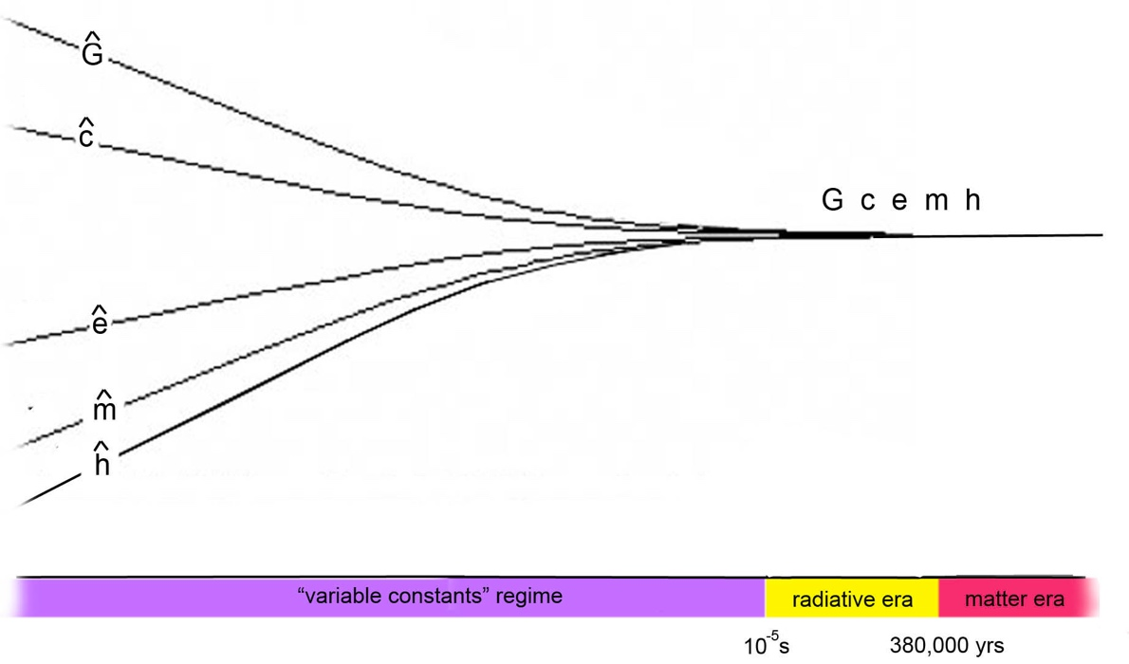

Fig. 6 : Schematic evolution of the "constants"

Looking back in time—after the transition from the matter-dominated era to the radiation-dominated era—we hypothesize that this "variable-constant" era emerges when the distance between baryons (and antibaryons) becomes comparable to their Compton wavelength, a point in time we place at around ${10}^{-5}$ second.

In the context of the Janus cosmological model [11], the evolutionary scheme during the matter-dominated era has already been described in reference [12]. This will be complemented by a description of the evolution during the radiation-dominated era in a subsequent paper. This presents no inherent difficulty; regarding positive mass, the evolution remains one of positive acceleration, dominated by the negative contribution of the negative mass.

As a first step toward integrating this "variable-constant" evolutionary scheme into the Janus cosmological model, and assuming that the negative world, composed of negative-mass antimatter, is subject to the same physical laws, we consider the following quantities:

( 102) $\left( \overline{c} , \overline{h} , \overline{G} , \overline{m} ,\overline{ e} ,{\overline{μ}}_{o} , \overline{a} , \overline{t} \right)$

Assuming that it obeys the same physical laws, we will have similar laws for the second species:

( 103) $\hat{\overline{c}} \sim \frac{1}{\sqrt{a}} ; \hat{\overline{h}} \sim a^{3/2} ; \hat{\overline{G}}\sim \frac{1}{a} ; \hat{\overline{m}} \sim a ;\hat{\overline{e}}\sim \sqrt{a } ; {\hat{\overline{μ}}}_{0} \sim a ; \hat{\overline{t}}\sim a^{3/2}$

12 - An alternative to inflation.

How, then, does the cosmological horizon evolve? This is where the benefit of this approach lies—the link to observation. The horizon is the distance traveled by light:

( 104) $H = \int^{t}{c dt}$
But in this different evolution, dominated by this gauge process:

( 105) $\hat{c} \sim \frac{1}{\sqrt{ a }} \sim {\hat{t}}^{- 1/3}$

So, without this variable speed-of-light regime:

( 106) $H = \int^{\hat{t}}{\hat{c} d\hat{t}} \sim \int^{\hat{t}}{{\hat{t}}^{- 1/3} d\hat{t}} \sim {\hat{t}}^{2/3 }\sim a$

( 107) $\boxed{ Cosmological horizon H \sim a }$

We are presented here with an evolutionary scheme in which the homogeneity of the universe is maintained throughout this evolutionary phase characterized by variable constants; this constitutes an alternative to the inflation model, based on the single hypothesis of a generalized gauge process centered on the requirement of invariance for all equations of physics.

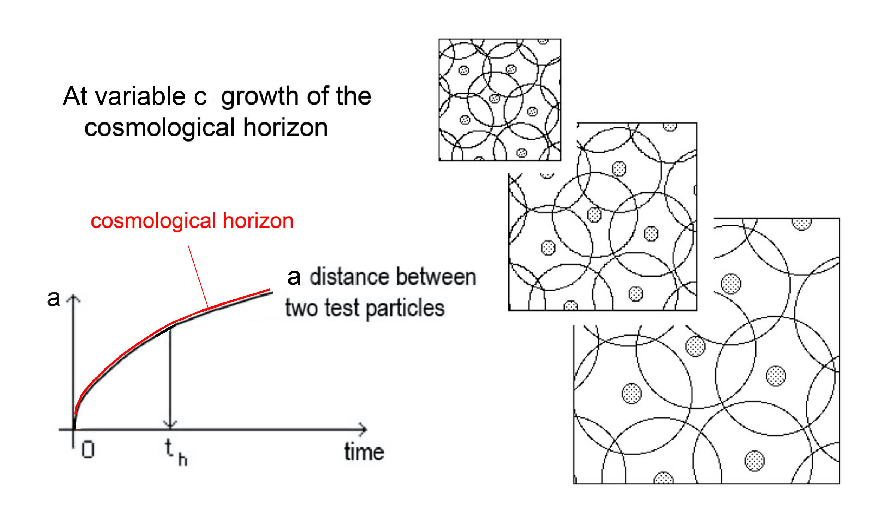

Fig.7 : Homogeneity ensured by a variation in the speed of light.

13 – The question of measuring time.

Cosmological models describe the evolution of the universe in terms of a quantity corresponding to the letter t, intended to represent time. However, this relies on a specific choice of coordinate system. Only a quantity that can be measured, even if only conceptually, using a clock belonging to the realm of physics qualifies as time. In the matter-dominated era, one can envision a conceptual clock consisting of two masses moving along the same circular orbit, centered on their common center of gravity. Measuring time then reduces to measuring the number of revolutions or an angle. Since the geodesics lie within planes in this scenario, this concept appears to be coordinate-independent. Similarly, the day corresponds to the Earth's rotation on its axis, the solar year to the Earth's revolution around the Sun, and what might be termed the galactic year to the solar system's revolution around its galaxy, the Milky Way.

If we follow this conceptual, non-relativistic clock back into the past—assuming it has avoided any collisions or exchanges with dangerous neighbors whose speeds (of thermal agitation) increase and approach the speed of light as we go further back—this clock corresponds to the classical conception of time.

But if the past encompasses an era of evolution with variable constants, then the components of our clock—its masses—are altered, as are the forces binding them. The geometric framework along which these masses trace their path varies as well. What, then, of the number of revolutions it completes?

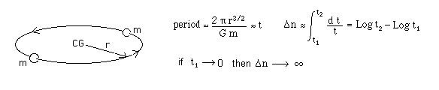
Fig. 8 : Our conceptual clock.

If we apply the effects of our generalized gauge phenomenon to the calculation of the period, that period varies as $a^{3/2}$. It therefore decreases, and as we look back into the past, our conceptual clock ticks faster and faster. As we approach a hypothetical time zero, the number of cycles completed tends toward infinity.

This yields the temporal equivalent of the myth of Achilles and the tortoise. Let us liken the history of the universe to a book. The character in my comic strips then leafs through the book backwards, attempting to discover, in the preface, the intentions its author might have recorded there.



Fig.9 : On the impossibility of accessing the "initial moment."

But he never reaches that preface, because the pages of the book tend to become increasingly thin and are therefore infinite in number.

This simply suggests that, when attempting to trace the universe's history back in time, quantum physics eventually comes into play and exerts its effects. Clarity will only be achieved when tools derived from general relativity and those from quantum mechanics can finally be combined through the quantization of the gravitational field—a task that, after decades, remains merely a project. This is an advance that, we believe, will entail constructing the geometric context of quantum mechanics—an extension that will, we believe, involve a systematic complexification of that geometric context.

14 - Integration of this variable-constant phase model into the Janus cosmological model.

In a future article, we will demonstrate how—starting from an initial state of perfect symmetry where the constants and the spatial and temporal scale factors of the universe's two components are identical—an instability inherent to this variable-constant regime causes the two systems to diverge violently (exponentially). Consequently, they come to possess distinct constants and space-time scales:$\left( \hat{a} ,\hat{t} \right) et \left( \hat{\overline{a}} ,\hat{\overline{t}} \right)$. This drift in constants ceases once the bayons and antibayons move apart by a distance exceeding their Compton wavelength (a point that would require further clarification, given that this Compton wavelength would itself increase in step with the scale factor). However, the tools currently employed—lacking a genuine geometric fusion that incorporates quantum mechanics—do not allow us to shed light on this specific issue ("For the possible, we act immediately; for the impossible, we ask for time").

Schematically, in the figure below:

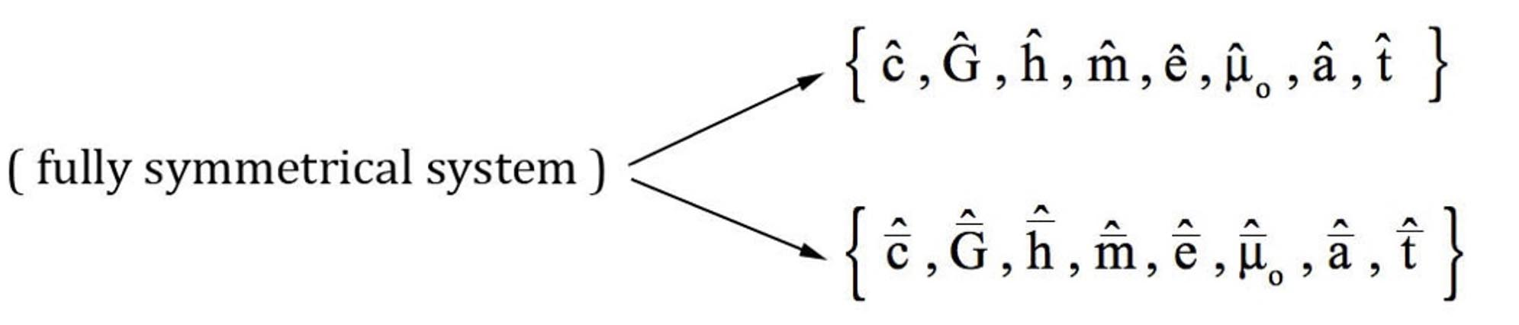

Fig. 10: Diagram of the appearance of asymmetry in the phase with variable constants

We might now have a way to specify the parameters linked to the second system. We already know one thing [12] regarding the scale factors (which, moreover, evolve differently, with acceleration in the positive sector and deceleration in the negative world):

( 108) $a > \overline{a}$

But in what proportion?

Gravitational instability can occur during the radiation-dominated era, as radiation acts as the source of the gravitational field. One can then adopt the Jeans approach and seek to determine the minimum wavelength for radiation density fluctuations such that the accretion time for additional radiation is shorter than the dissipation time for the radiation already accreted. This yields a value corresponding to the cosmological horizon.

Thus, these fluctuations would be present, yet we would have no way of detecting their existence.

And this brings us back to what emerges from this era of variable constants: the order of magnitude of the cosmological horizon is comparable to the scale factor in each of the two populations. However, we have $a > \overline{a}$, so:

( 109) $\overline{H} < H$

The two entities interact gravitationally—or, to be more precise, anti-gravitationally—at every stage of cosmic history. Consequently, fluctuations occurring in the negative realm must leave their imprint on the positive realm across all epochs: during the matter-dominated era, immediately following decoupling, the organization of negative mass into a regular distribution of vast, massive spheroidal conglomerates imparts a void-like structure to the positive mass, resembling "contiguous bubbles":

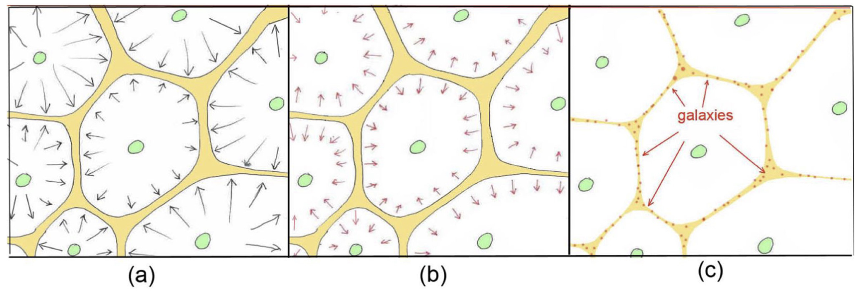

Fig. 11: Formation of the large-scale structure. (a): The negative mass (green) forms a regular distribution of spheroidal clusters, imparting a void-like, contiguous-bubble structure to the positive mass (yellow). (b): The positive mass, having been strongly heated, undergoes rapid cooling via radiative losses. (c): Galaxies form. [13].

However, this interaction persists in the epochs prior to decoupling. We therefore propose a different interpretation of the CMB fluctuations:

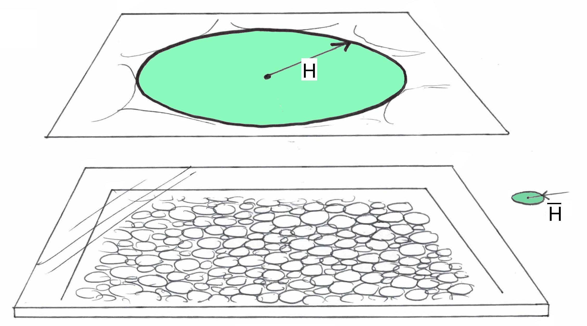

Fig. 12: Our interpretation of the CMB inhomogeneity.
$H$ and $\overline{H}$are the cosmological horizons of the two universes.

The non-linear radiation density fluctuations arising in the negative world leave a faint imprint on the positive world. In our view, this explains the CMB fluctuations. In very schematic terms, this yields the order of magnitude of the ratio between the two horizons (and thus the two scale factors), which differ by two orders of magnitude.

( 110) $\frac{\overline{a}}{a} \sim \frac{1}{100}$

Work is currently underway, focusing on the study of these fluctuations in the radiation density field within the "negative world" via gravitational instability (specifically Jeans instability), that will enable a comparison of the two models.

That being said, in our model this discrepancy arose during the dual regime of variable constants, in which we have:

( 111) $c \sim \frac{1}{\sqrt{ a }}$ $\overline{c} \sim \frac{1}{\sqrt{\overline{ a} }}$

Whence:
( 112) $\frac{\overline{c}}{c} \sim 10$

The scientific community’s view that interstellar travel—on a human scale and at necessarily non-relativistic speeds—is forever impossible stems from the sheer duration involved. However, based on this new perspective, if a vehicle could invert its mass, it might undertake the journey via a sort of parallel universe, operating in a negative-mass regime, thereby reducing travel times by a factor of 1,000.

( 113) $travel time × \frac{1}{100} × \frac{1}{10} = \frac{1}{1000}$

This would then place neighboring star systems—at a distance of around ten light-years, within reach, accessible via voyages undertaken at one-tenth the speed of light within this other sheet, with a duration on the order of an Earth month.

Regarding the phenomenon of mass inversion, we find a natural version of it in the phenomenon of plugstars [14].

For a long time, authors have envisioned the possibility of passing from one sheet to another via wormholes. However, for this to be feasible, such structures would need to exist naturally in the cosmos, involving sufficient mass to ensure that tidal forces do not tear apart the vessels venturing into them. Yet, a different scenario can be envisaged.

15 - Mass transfer via surgery.

If inverting a mass M required an energy expenditure on the order of Mc², the process would clearly have to be relegated to the realm of science fiction, given our current capabilities. However, let us examine the formula below.

In differential topology, surgery is an operation that consists of excising certain regions of a manifold and reattaching the resulting boundaries according to a specific identification. This operation alters the manifold's topology. In differential geometry, the resulting manifold must then be endowed with a metric compatible with the imposed physical conditions. When applied to two initially disjoint sheets, such an operation conceptually allows for the excision of a region from each sheet and the local reattachment of their boundaries.

Let us illustrate the principle of such topological surgery using a series of drawings. Imagine two adjacent, flat sheets, $F_{1}$ and $F_{2}$. One is white, the other blue. A closed curve has been drawn on $F_{1}$, defining a region, a simple disk, that we wish to transfer to sheet $F_{2}$.

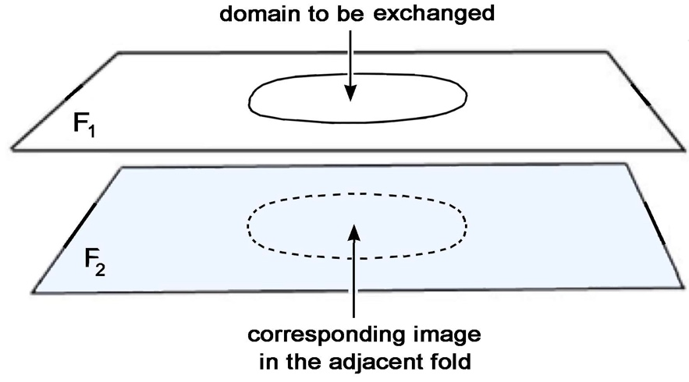

Fig. 13 : Two adjacent sheets of 2D Euclidean space.

To carry out this operation, we will create a curvature in the vicinity of this boundary. To visualize this, we will cut these two planes. The curvature introduced into sheet $F_{1}$ produces an "induced curvature" in the adjacent sheet $F_{2}$, which would correspond to two geometries with coupled metrics, as in the Janus cosmological model [13].

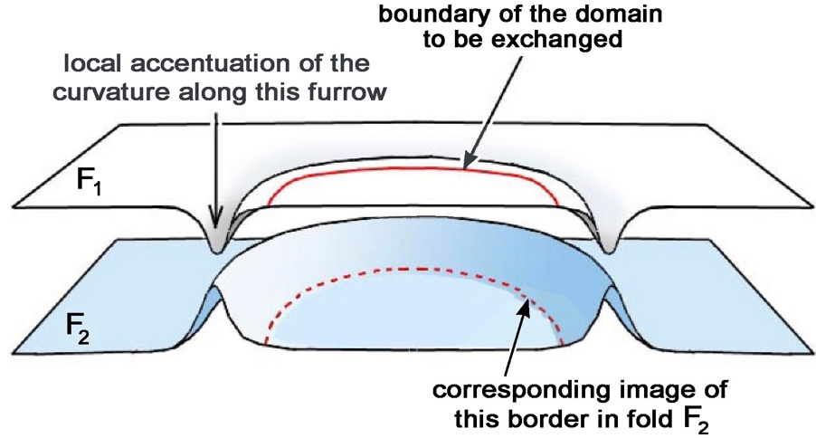

Fig. 14 : Creation of a curvature in the vicinity of a curve
delimiting a domain and its image in the adjacent sheet

The two sheets are depicted as immersed in $R^{3}$. A critical state is reached when the curvature becomes infinite along the boundary of the domain where two tangent planes exist. One can visualize the two sheets coming into contact along the closed curve, with the induced curvature causing the tangent planes to align along that curve. This situation lends itself to what is known in topology as "surgery." The white portion of sheet $F_{1}$ , lying outside the boundary curve, then connects to the interior of the blue disk located on sheet $F_{2}$. A symmetrical phenomenon occurs where the blue part of sheet $F_{2}$. (outside the image of the circular curve) suddenly extends into the white disk of sheet $F_{1}$.

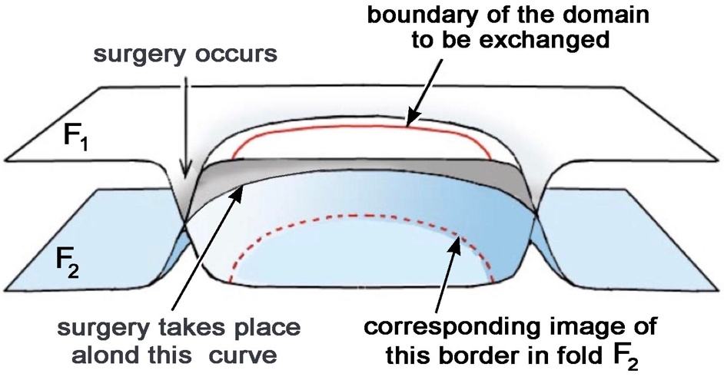
Fig.15 : 2D surgery.

The curvatures disappear, resulting in a final configuration with two adjacent planar regions where the interiors of the boundary curve of domain $F_{1}$ and its image in the adjacent portion of $F_{2}$ have been swapped.

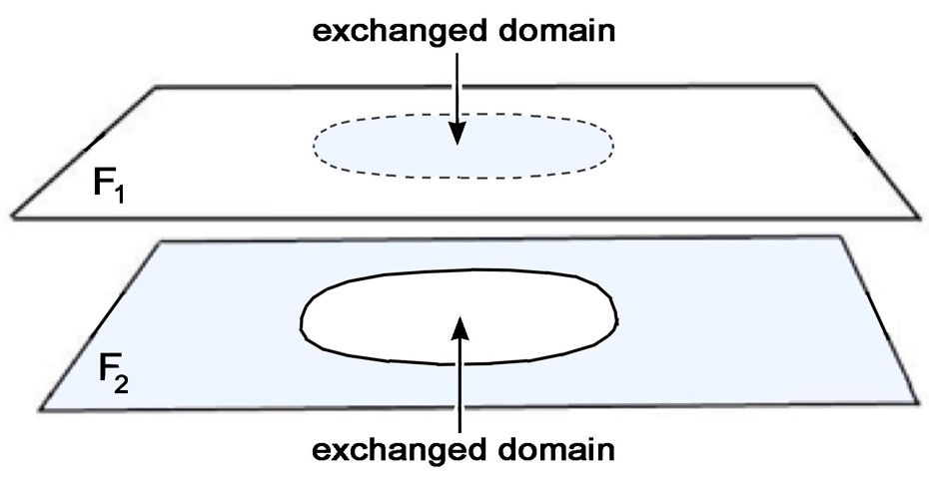

Fig. 16 : The two domains have been exchanged.

One can then envision such a situation in 3D, where balls $B_{3}$, located within two 3D sheets bounded by S2 spheres, are exchanged.

The surgical approach envisaged here therefore suggests a possibility of a different nature: the geometric transformation would not necessarily involve the entire volume occupied by the mass, but could be triggered by a very high concentration of energy within an extremely thin layer surrounding it.

One can envision, as a prospective example, a material whose nuclei are brought into metastable excited states. Certain nuclear isomers do indeed store excitation energies on the order of MeV per nucleus for exceptionally long periods. Their controlled, large-scale production could—in a still-speculative future—rely on coherent gamma-ray photon sources tuned to appropriate nuclear transitions. Such sources do not currently exist with the required characteristics. The fundamental question then becomes quantitative: what volumetric energy density—or, in the limit of a very thin layer, what surface energy density—would need to be achieved to trigger the envisioned topological change?

At this stage, general relativity and quantum mechanics, when used separately, likely cannot provide a meaningful answer. Classical general relativity describes the gravitational effect of an energy-momentum distribution but offers no microscopic mechanism for such controlled topological surgery. Conversely, quantum mechanics describes nuclear states and their transitions without providing a quantized dynamics of geometry itself. The answer to this question will only emerge once general relativity, and more specifically the Janus Cosmological Model, has been merged with quantum mechanics within a single, complex geometric framework.

If such a transfer were to become physically feasible and controllable, the technological consequences would be immense. In particular, one could envisage transferring materials that currently pose major storage challenges—foremost among them, high-level radioactive waste. An unexpected consequence of such a process would immediately become apparent. Once the mass had been transferred to the conjugate sector, the container that previously held it would find itself in the physical state corresponding to the adjacent region of spacetime: a near-perfect vacuum. By then allowing the external atmosphere to rush into this chamber through a turbine, a portion of the energy associated with this expansion could be converted into electrical energy. This would not, of course, constitute the creation of energy. In the Janus model, transfers between sectors operate within a dynamic framework where the energy balance must be viewed globally. Consequently, conservation cannot be assessed based solely on the energy content of one of the two sectors. Initial applications of the Janus model equations [13] immediately reveal a law of energy conservation that extends across both sheets. This constraint would govern the mass transfer resulting from the exchange of contents between adjacent domains.

16 - Conclusion :

Within the framework of the Janus cosmological model, we propose, as an alternative to the inflationary scenario, the existence of a phase preceding decoupling and the radiation-dominated era, during which the six fundamental physical constants, as well as the space and time gauge factors of the two sheets, are involved in a generalized gauge process. This process arises simultaneously from the invariance of the fundamental equations of physics, the invariance of the Einstein constant appearing on the right-hand side of the model's coupled field equations, and the invariance of the fine-structure constant. Lorentz invariance is thus preserved within each of the two sheets.
This correlated evolution is accompanied by the conservation of all forms of energy. All characteristic lengths evolve in proportion to the space scale factors of the two sheets, notably their respective cosmological horizons.

Since radiation itself acts as a source of the gravitational field, Jeans instability can also occur during the radiation-dominated era. When the characteristic wavelength is on the order of the cosmological horizon, the corresponding fluctuations cannot be observed within a single causal domain. However, the fundamental asymmetry of the Janus model alters this situation: because the cosmological horizon of the negative-mass sector is much smaller than that of the positive-mass sector, fluctuations developing in the former can produce effects in the latter as it enters its matter-dominated era. This mechanism thus offers a possible origin, alternative to inflation, for the fluctuations recorded in the CMB.

Since radiation itself acts as a source of the gravitational field, Jeans instability can also occur during the radiation-dominated era. When the characteristic wavelength is on the order of the cosmological horizon, the corresponding fluctuations cannot be observed within a single causal domain. However, the fundamental asymmetry of the Janus model alters this situation: because the cosmological horizon of the negative-mass sector is much smaller than that of the positive-mass sector, fluctuations developing in the former can produce effects in the latter as it enters its matter-dominated era. This mechanism thus offers a possible origin, alternative to inflation, for the fluctuations recorded in the CMB.

Naturally, this hypothesis must be tested against observation. In particular, it requires constructing the spectrum of non-linear fluctuations developing in the negative sector during its radiation-dominated era, then calculating their transfer to the positive sector and comparing the resulting spectrum with CMB data. The difference of approximately two orders of magnitude found between the scale factors constitutes, in this regard, a first quantitative characteristic of the proposed mechanism.

Within the framework of the model, the asymmetry arising from phases with variable constants also leads to a speed of light that is an order of magnitude higher in the negative sector. If a material object could transition to this sheet by reversing the sign of its mass, the latter would then act as a "parallel universe," allowing for a considerable reduction in apparent interstellar travel times.

Finally, we have outlined a geometric transition mechanism between adjacent domains, akin to a form of "surgery", that relies on energy concentration within a layer surrounding the object in question. Mechanisms for the storage and release of nuclear energy, particularly involving long-lived metastable states excited by gamma radiation, have been proposed as conceptual avenues. Within this hypothetical framework, such a transition would also necessitate considering the transfer of unwanted material, specifically radioactive waste.

However, these latter considerations must be clearly distinguished from the cosmological results developed in this article. At this stage, it is not possible to calculate the value of the critical energy required for such a transition. Such an assessment would require a theory in which quantum mechanics and gravitation are integrated into a single geometric framework. Constructing such a framework, as well as quantitatively calculating the spectrum of cosmological fluctuations predicted by the mechanism presented here, therefore represents a natural avenue for future work.

References.

[1] K.Lodha and Al. Extended Dark Energy analysis using DESI DR2 BAO measurements. arXiv 2503.14743v1/Astro-ph-CO/18 mars 2025+
[2] J.P.Petit, G.D’Agostini : Negative Mass hypothesis in cosmology and the nature of dark energy. Astrophysics And Space Science,. A 29, 145-182 (2014)
[3] J.P.PETIT : Cosmological model with variable velocity of light. Modern Phys Letters A3, 1988, pp. 1527
[4] J.P.PETIT, Twin Universe Cosmology, Astrophys. and Sp. Science, 226, 273-307, 1995
[5] Weinberg S. The First Three Minuts. A Modern View of the Origin of the Universe. New York basic books, 1993.
[6] A.ALBREICHT & J.MAGUEIJO: Phys. Rev. 59. 04516 (1999)
[7] J.MAGUEIJO : Report in Progress : Phys 66 , 2025
[8] J.MOFFAT International Journal of Modern Physics D 2, 351, (1993)
[9] J.Moffat. Variable speed of light cosmology. Primordial fluctuations and gravitational waves. European Physical Journal C. Vol.76 n° 130 (2016)
[10] E. A. Milne, Kinematic Relativity: A Sequel to Relativity, Gravitation and World-Structure, Oxford University Press, 1948, chapitre VIII.
[11J.P.Petit, F.Margnat, H.Zejli : A bimetric cosmological model on Andreï’s twin universe approach. The European Physical Journal. Vol. 84 :N°1126 (2024)
[12] J.P.Petit, G.D’Agostini : Negative Mass hypothesis in cosmology and the nature of dark energy. Astrophysics And Space Science,. A 29, 145-182 (2014)
[13] J.P.Petit, F.Margnat, H.Zejli : A bimetric cosmological model on Andreï’s twin universe approach. Th European Physical Journal. Vol. 84 :N°1126 (2024)
[14] J.P.Petit, G.D’Agostini. Alternative to black holes, gravastars and plugstars. Journal of Modern Physics, Vol.16 n°10, October 2025

Jppetit1937@yahoo.fr

