Curves spiraling towards the center of black holes are virtual geodesics

Jean-Pierre Petit et Gilles d’Agostini
_________________________________________________________________________

Keywords : virtual geodesics, Lagrangian, Flamm surface, Schwarzschild exterior solution.
__________________________________________________________________________

Abstract : Geodesics are defined as the shortest paths. When a geometric structure is defined by its metric, a system of Lagrange equations can be constructed, using a variational approach, to represent these curves. If the Lagrange function contains derivatives with respect to the element of length ds, the same system of equations is obtained by replacing ds with its square. The resulting curves are then true geodesics, where the length is real, in the region of space corresponding to the surface or hypersurface's definition space. Outside this region, we obtain real curves, but with purely imaginary lengths, which we then call virtual geodesics. The torus and sphere are given as examples. It is shown, in the case of the cosmological application of the Schwarzschild exterior solution, that curves considered to spiral towards a central singularity are in fact virtual geodesics, devoid of physical reality.

__________________________________________________________________________

Consider a surface, or a hypersurface, defined by its metric:

- $ds^{2} = g_{μν} dx^{μ}dx^{ν}$

Let us define the domain where the variables are defined, real. We will simply assume that they are real numbers, positive or negative. If we manage to express this metric in diagonal form, in a suitable coordinate system:

- $ds^{2} = g^{μμ} {dx^{μ}}^{2}$

When the metric is diagonalyzed the series of signs affecting the terms $g_{μμ}$ form its signature. Consider a curve 𝑥^{𝑖}(𝑝) in this n-dimensional space, where the points are located using a parameter p. The length between two points A and B on this curve corresponds to the equation

- $\int_{\hat{AB}}{ds} = \int_{\hat{AB}}{\sqrt{ g_{μν} dx^{μ}dx^{ν} } = \int_{\hat{AB}}{\sqrt{ g_{μν} \frac{dx^{μ}}{dp}\frac{dx^{ν}}{dp} }dp }}$
Posing :
- $\dot{x^{i}} = \frac{d x^{i}}{dp}$

This integral then has the form:

- $\int_{\hat{AB}}{L({ x}^{i}, \dot{x^{i}} ) dp}$

L is then a Lagrange function and the curves representing extrema of the values ​​of this function, in particular minima, i.e. geodesics, are solutions of n Lagrange equations:

- $\frac{d}{dp}\left( \frac{∂L}{ ∂{\dot{x}}^{i}}\right) = \frac{∂L}{∂x^{i}}$

Now let's imagine that we are considering constructing the solution curves of the Lagrange equations associated with the Lagrange function:

(7) $Λ = L^{q}$

The corresponding Lagrange equations will be different because there will be an additional term:
(8) $\frac{1}{L} \frac{∂L}{∂{\dot{x}}^{i}} \frac{dL}{dp} +\frac{d}{dp}\left( \frac{∂L}{ ∂{\dot{x}}^{i}}\right) = \frac{∂L}{∂x^{i}}$

What would it take for the equations associated with the Lagrange function λ to be the same as those derived from the function F? It would suffice for the function F to be constant along all curves. And for this, there is a proven solution:

The parameter defining the points on the curve must be precisely the length s.

Dividing (1) by ds², we get:
$$1 = g_{μν} {\dot{x}}^{μ}{\dot{x}}^{ν}$$

In other words, if we are looking for the geodesics of the surface defined by the metric (1) we can reason not with the length, but with the action constructed from the bilinear form:

(10) $J = \int_{\hat{AB}}{ds} = \int_{\hat{AB}}{( g_{μν} {\dot{x}}^{μ}{\dot{x}}^{ν} ) ds^{2} }$

But, under these conditions, we will see that we can find portions of curves, quite real, but for which the bilinear form has a negative value, that is to say, for which the length is purely imaginary. We will call these curves pseudo-geodesics. Let's give a very clear example. Consider the metric:

(11) $ds^{2} = r^{2}dφ^{2} + \frac{dr^{2}}{{-R}^{2}+ {r_{0}}^{2} - r^{2}+ 2 r R}$

With $R > r_{0}$ > 0

Consider the radial paths $( dφ = 0)$. The lenght becomes :

$$ds = \frac{dr}{\sqrt{{-R}^{2}+ {r_{0}}^{2} - r^{2}+ 2 r R}}$$

For it to be real, the following conditions must be met:

- Either $r < R - r_{0}$

- Either $r > R + r_{0}$

Which define the definition domain. The lenght s is :

(12) $s = \int{\sqrt{{ r}^{2}{\dot{φ}}^{2} + \frac{\dot{r^{2}}}{{-R}^{2}+ {r_{0}}^{2} - r^{2}+ 2 r R} } ds}$

But we know that we can construct geodesics of this 2-surface based on the Lagrange equations derived from the Lagrange function:

(13) $F ( r , \dot{r , \dot{φ} ) = }{ r}^{2}{\dot{φ}}^{2} + \frac{\dot{r^{2}}}{{-R}^{2}+ {r_{0}}^{2} - r^{2}+ 2 r R}$

Write the Lagrange equation :
(14) $\frac{d}{ds}\left( \frac{∂F}{∂\dot{φ} }\right) = \frac{∂F}{∂φ} = 0$

h being a constant, we get :
(15) $\dot{φ} = \frac{h}{r^{2}}$

We do not need to write the second equation since we have the relationship:

(16) $1 = { r}^{2}{\dot{φ}}^{2} + \frac{\dot{r^{2}}}{{-R}^{2}+ {r_{0}}^{2} - r^{2}+ 2 r R}$

Combining to (15) we get the following differential equation :

(17) $d φ = \frac{± h dr}{ r^{2}\sqrt{\left({-R}^{2}+ {r_{0}}^{2} - r^{2}+ 2 r R\right)\left( 1 - \frac{h}{r^{2}}\right) }}$

Thanks to which we digitally construct the planar projections of geodesics, within the domain of definition, which we will designate as real geodesics:

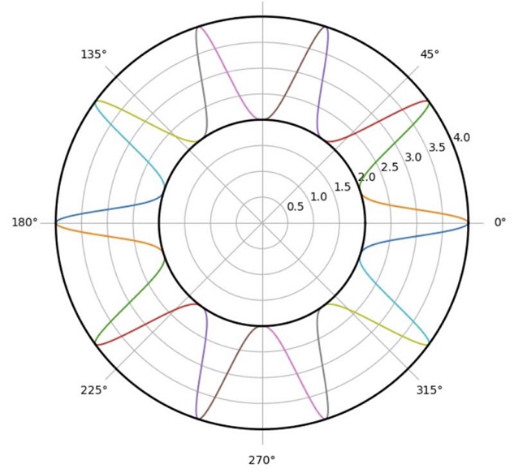
Fig.1 : Real geodesics.

We will then construct what we will call virtual geodesics, that is to say real curves, derived from Lagrange's equations, but for which the length is purely imaginary.

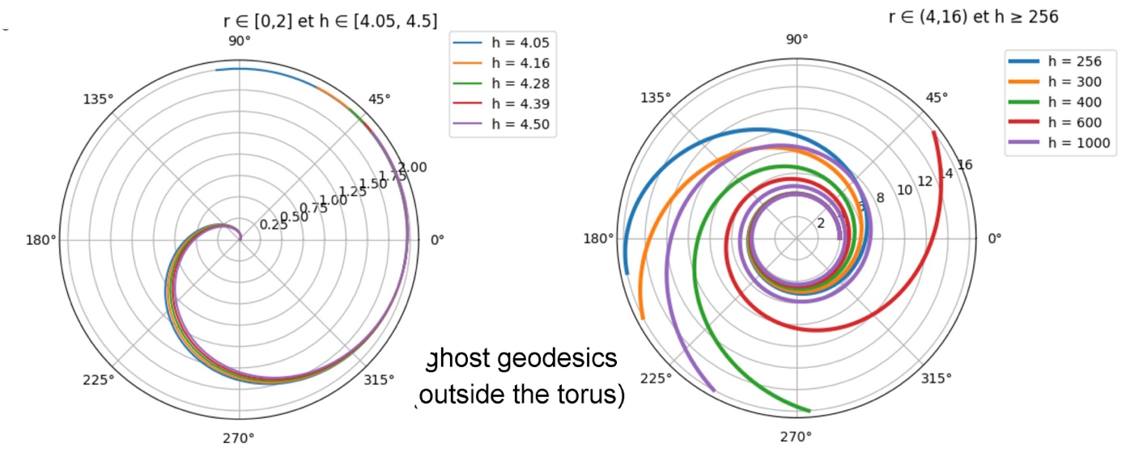

Fig.2 : : Virtual geodesics.

The figure on the left shows some curves for r < R – r₀. The direction of winding depends on the sign of h. The geodesics are tangent to the limiting circle. They wind infinitely towards the center where $dφ/dr$ tends to infinity. The curves on the right give the curves for r > R + r0. They also have spiral shapes, the direction of winding also depending on the sign of h. The curves are tangent to the circle of radius r = R + r₀. They then spiral to infinity. So what is this surface defined by its metric? This object exhibits rotational symmetry (invariance under translation along $φ$). We can embed it in $R^{3}$, described using cylindrical coordinates$( r , φ , z)$, which we translate as:

(18) $ds^{2} = {dr^{2} + dz^{2}}^{}= dφ^{2} + \frac{dr^{2}}{{-R}^{2}+ {r_{0}}^{2} - r^{2}+ 2 r R}$

We are going to construct the meridian line:

(19) $dr^{2} + dz^{2}= \frac{dr^{2}}{{-R}^{2}+ {r_{0}}^{2} - r^{2}+ 2 r R} = \frac{dr^{2}}{z^{2}}$

This equation is satisfied for:

(20) $r = R + r_{0} cosθ z = r_{0} sinθ$

This meridian is a circle, and our surface is a torus. Its complete metric can be represented using two angles, in a more familiar form:

(21) $ds^{2} = {r_{0}}^{2} dθ^{2}+ {( R + r_{0} cosθ )}^{2} dφ^{2}$

The non-contractibility of the object appears when we consider paths with constant $φ$ or constant $θ$.

We have thus provided it with two sets of real curves, solutions to the system of Lagrange's differential equations. But only the curves that correspond to the domain of definition have a real length.

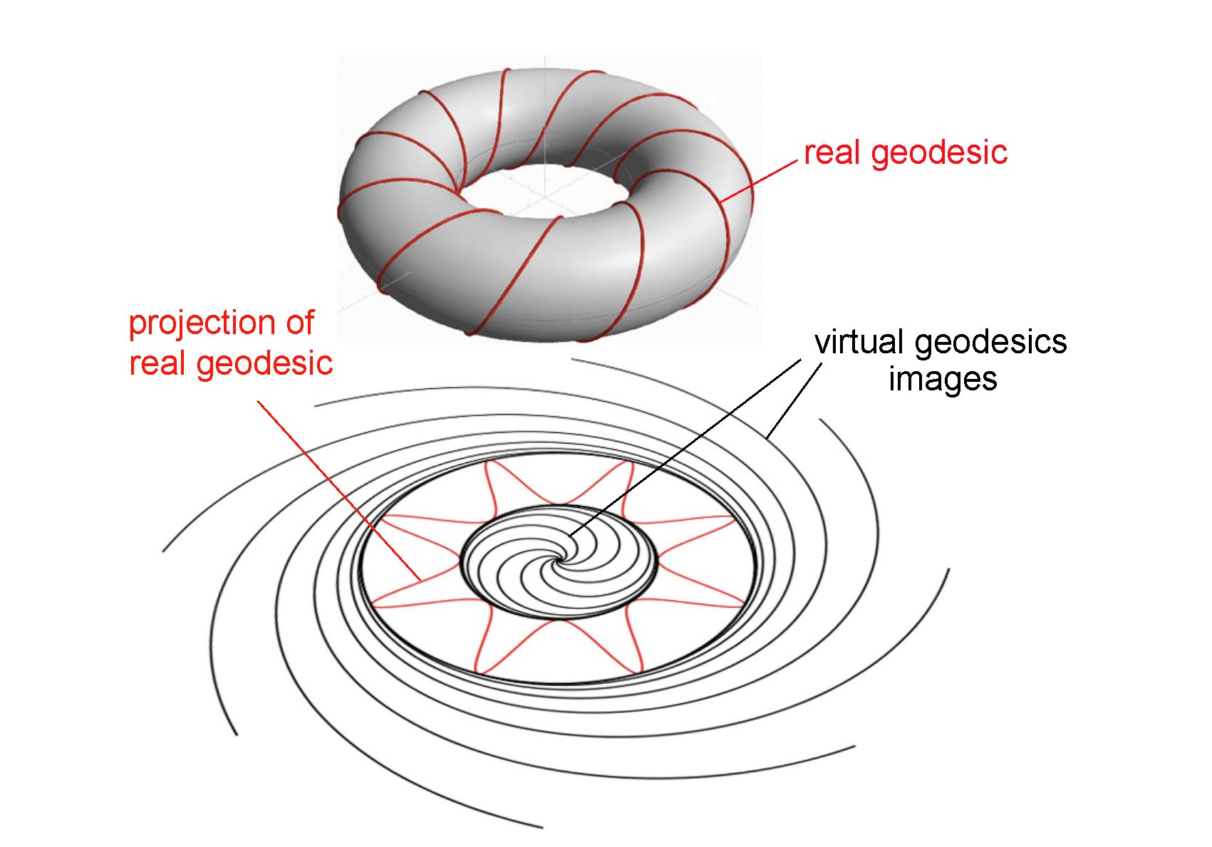
Fig.3 : The torus, equipped with its real and virtual geodesics.

Consider this other metric:
(22) $ds^{2} = r^{2}dφ^{2} + \frac{R^{2} dr^{2}}{R^{2}-r^{2}}$

Here again, we will take Lagrange's function as:

(23) $r^{2}{\dot{φ}}^{2} + \frac{R^{2} {\dot{r}}^{2}}{R^{2}-r^{2}}$

Where, once again :

(24) $\dot{φ} = \frac{dφ}{ds} \dot{r} = \frac{dr}{ds}$

Under these conditions, the Lagrange equations associated with this function yield curves whose part such that ds > 0 are geodesics. But here again, we obtain pseudo-geodesics, real curves corresponding to a description in polar coordinates, but equipped with a purely imaginary length. As in the previous metric, one of these equations is:

(25) $\dot{φ} = \frac{h^{2}}{r^{2}}$

By combining this with the following relation, which follows from (24):

(26) $1 = r^{2}{\dot{φ}}^{2} + \frac{R^{2} {\dot{r}}^{2}}{R^{2}-r^{2}}$

We obtain the following differential equation:

(27) $d φ = \frac{h R}{r}\frac{ dr}{ \sqrt{\left(R^{2} - r^{2}\right)\left( r^{2} - h^{2}\right) }}$

The solutions h < r < R give the actual geodesics, and those for R < r < h give the pseudo-geodesics. Below are the curves for R=1:

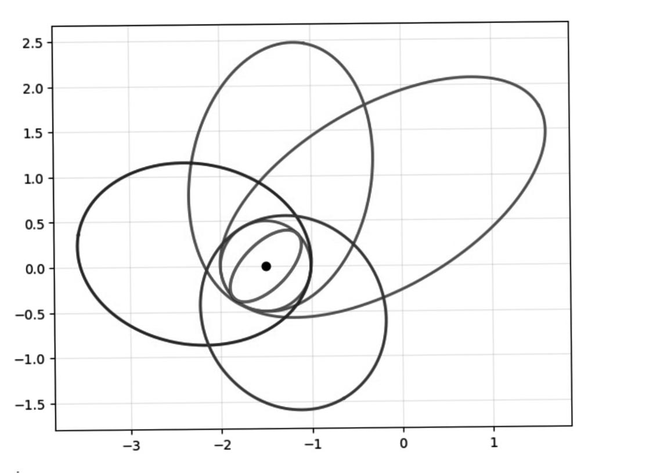

Fig.4 : Projections of geodesics and pseudo-geodesics of a sphere of radius 0.5

Let's determine the nature of these curves. Let's write:

(28) $\frac{dr}{dφ } = \frac{r}{h R } \sqrt{ ( r^{2}- h^{2}) ( R^{2}- r^{2}) }$

Posing :
(29) $r = \frac{1}{u}$

(30) $- \frac{dφ}{du} = \frac{1}{h R } \sqrt{ ( 1 - h^{2}u^{2}) ( R^{2}u^{2}- \frac{11}{u^{2}} ) }$

(31) $\frac{d^{2}u}{dφ^{2}} + u = \frac{1}{h^{2}}$

(32) $u = \frac{1}{h^{2}} + A cos ( φ - φ_{0})$

The parameter R disappears.

(33) $r = \frac{h^{2}}{1 + e cos ( φ - φ_{0}) }$

With 0 < e < 1, these curves are ellipses. Equation (27) shows that these curves are tangent to the circle of radius R. The equation holds true both for h < r < R (true geodesics) and for
h > r > R. Thus, the virtual geodesics are also ellipses. What is this geometric object, defined by the metric (22)?

Let's make the change of variable:

(34) $r = R sin θ$

We immediately obtain the metric of the sphere:

(35)
$$ds^{2} = R^{2} \left(dθ^{2}+ sin^{2}θ dφ^{2}\right)$$

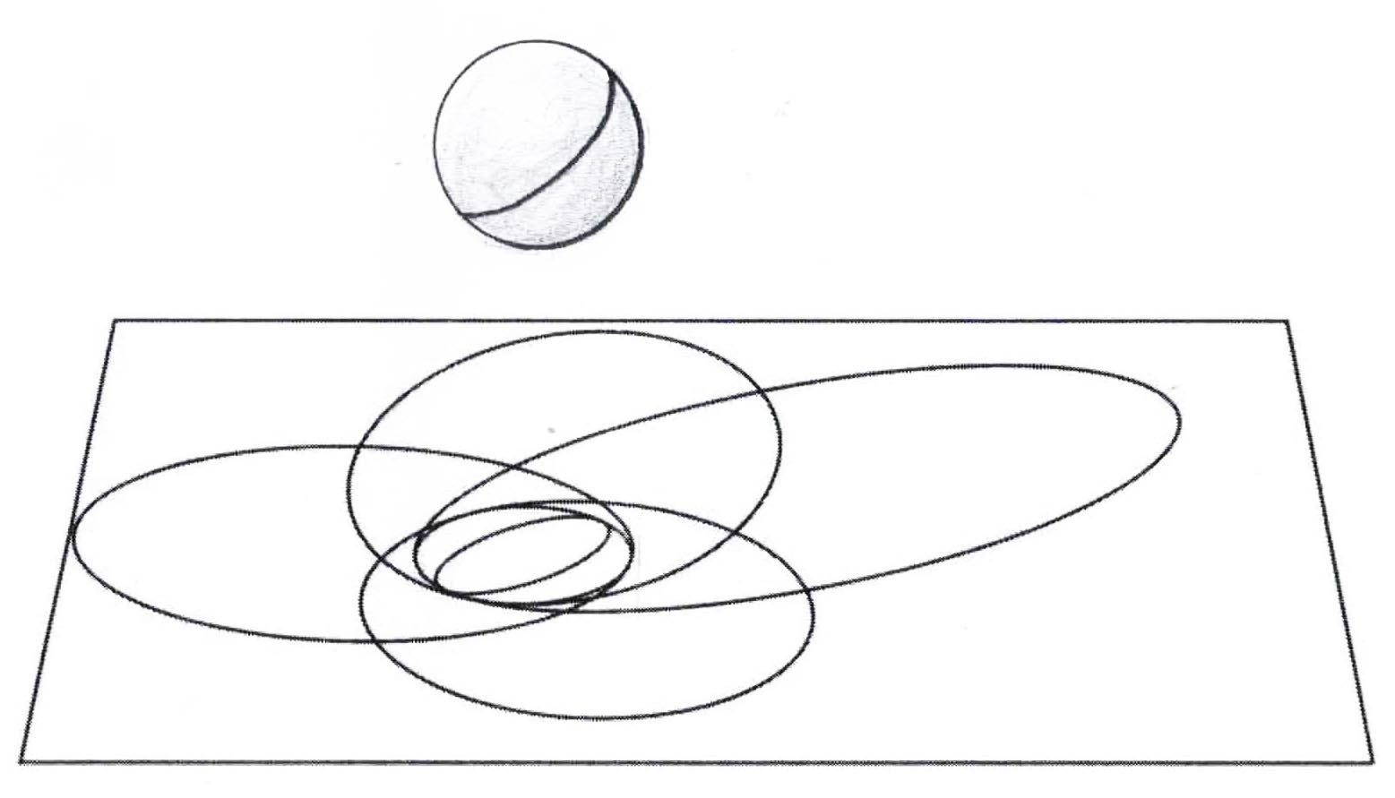
Fig.5 : Projection d’une géodésiques et de pseudo-géodésiques de la sphère

Plane projections, approximated as virtual geodesics of the sphere, also tend towards infinity. But unlike the virtual geodesics of the torus, which are spiral-shaped, those of the sphere are ellipses. Such a study could be considered a curiosity, of little mathematical interest. All we have demonstrated is that the plane projections of the virtual geodesics of the object associated with the metric (22) are ellipses. But it takes on a completely different significance when astrophysicists confuse what is real with what is imaginary.

In 1916, the Austrian mathematician Karl Schwarzschild published [1] the first exact solution to Einstein's equation: a homogeneous, stationary, and spherically symmetric solution. He located his solution in a space $( t , x , y , z )$, then quickly converted it to spherical coordinates with:

(36) $r = \sqrt{ x^{2}+ y^{2}+ z^{2} }$

This implies that its coordinate $r ≥ 0$.

The construction of his solution reveals a parameter α, which physical considerations dictate must be positive. He then introduces an "intermediate quantity" R, defined by:

(37) $R = {\left( r^{3}+ α^{3}\right)}^{1/3} ≥ α$.

And his solution is presented in the following form:
(38)
$${ds}^{2} = \left( 1 - \frac{α}{R} \right)c^{2}dt^{2}- \frac{dR^{2}}{1 - \frac{α}{R}} - R^{2}\left( dθ^{2}+ sin^{2}θ dφ^{2} \right) R ={\left( r^{3}+ α^{3}\right)}^{1/3}$$

The condition on R means that this hypersurface is inherently non-contractile. This can be illustrated more clearly (which Schwarschild did not do at the time) by returning to coordinates $\left(t , r, θ , φ\right)$ :
(39)
$$ds^{2}= \frac{{\left( r^{3}+α^{3}\right)}^{1/3}- α}{{\left( r^{3}+α^{3}\right)}^{1/3}}c^{2}{dt}^{2} - \frac{r^{4} dr^{2}}{\left( r^{3}+α^{3}\right)\left[{\left( r^{3}+α^{3}\right)}^{1/3}- α\right]}$$

$$- {\left({ r}^{3}+α^{3}\right)}^{2/3}\left( dθ^{2}+sin^{2}θdφ^{2}\right)$$

Time passes and today this solution is presented in a form described as "standard", like this:

(40) ${ds}^{2} = - \left( 1 - \frac{α}{r} \right)c^{2}dt^{2} + \frac{dr^{2}}{1 - \frac{α}{r}} + r\left( dθ^{2}+ sin^{2}θ dφ^{2} \right)$

Note the inversion of the signature, changing from $\left( + - - - \right)$ to $\left( - + + + \right)$. This is an error, pointed out by the mathematician Abrams in 2001 [2]. He attributes it to the mathematician David Hilbert, in the article where he intends to integrate what he believes to be the solution found by Schwarzschild in an article entitled "Foundations of Physics" [3]. In his approach, Hilbert treats any solution to Einstein's equations not as a metric, defining a length whose element is necessarily positive, but as a bilinear form. Furthermore, he develops his own vision of relativity, which is that presented in 1902 by the mathematician Henri Poincaré, who sees spacetime as a four-dimensional space where the space coordinates (x, y, z) are real, and the fourth, the time coordinate, designated by the letter l, is purely imaginary:

(41) l = it

Let us briefly digress here to explain the origin of Hilbert's error, pointed out by Abrams eighty-five years later, in an article that had no impact on the community of those who henceforth called themselves "cosmologists." Like Schwarzschild, Hilbert introduced what he believed to be the most general solution to Einstein's stationary, spherically symmetric equation (presented as a bilinear form):

(42) $F\left(r\right) dr^{2} + G\left(r\right) \left(dθ^{2}+\sin^{2}θ dφ^{2}\right) + H\left(r\right) dl^{2}$

He then equates the term G(r) to r², which seems to him to be a simplification and to allow easier convergence towards the fact that, for r tending towards infinity, this expression converges, not towards the Lorentz metric, in spherical coordinates:

(43) $ds^{2} = c^{2}dt^{2}- dr^{2} - r^{2}\left( dθ^{2}+ sin^{2}θ dφ^{2} \right)$

Here is its bilinear form, as r tends towards infinity, with its sign convention:

(44) $dr^{2} + r^{2}\left( dθ^{2}+ sin^{2}θ dφ^{2} \right) + c^{2}$dl²

Using this simplification, Hilbert then presents his solution, in bilinear form:

(45) $G\left(dr, dθ, dφ, dl\right)=\frac{r}{r-α}dr^{2}+r^{2}dθ^{2}+r^{2}\sin^{2}θ dφ^{2}-\frac{r-α}{r}dt^{2}$

In cosmology, length is proportional to proper time, which is necessarily positive. Hilbert then introduces this as one of the two lengths he defines as follows. The first, associated with "timelines," is designated by him as proper time:

(46) $τ=\int{\sqrt{-G\left(\frac{{dx}_{s}}{dp}\right)}dp}$

The second is :
(47) $λ=\int{\sqrt{G\left(\frac{{dx}_{s}}{dp}\right)} dp}$

Decades have passed. Today, all articles and books contain what is considered the "standard form" of the Schwarzschild solution:

(48) ${ds}^{2} = - \left( 1 - \frac{α}{r} \right)c^{2}dt^{2}+ \frac{dr^{2}}{1 - \frac{α}{r}} + r^{2}\left( dθ^{2}+ sin^{2}θ dφ^{2} \right)$
The coordinate r is then considered a "radial variable", simply positive. The proper time τ is then defined by the relation (with c = 1):

(49) $dτ^{2} = - ds^{2}$

However, this geometry had been perfectly defined as early as 1916 by the mathematician Ludwig Flamm [4]. He did not make Hilbert's mistake and explicitly started from the form (32), from Schwarzschild's publication [1].

Since the solution is invariant under time translation, he considers that he must study the geometry of a 3D hypersurface undergoing a translation along the time coordinate. He then focuses on the spatial part of the metric, describing this 3D hypersurface, and performs a cut at constant θ, and more precisely at θ = π/2. He then obtains a two-dimensional object and observes that it can be embedded in ℝ³. He then constructs its meridian, which is a recumbent parabola, whose equation is [4]:

(51) $z^{2} = 4 α ( r - α )$

Below is a reproduction of the figure from his article:

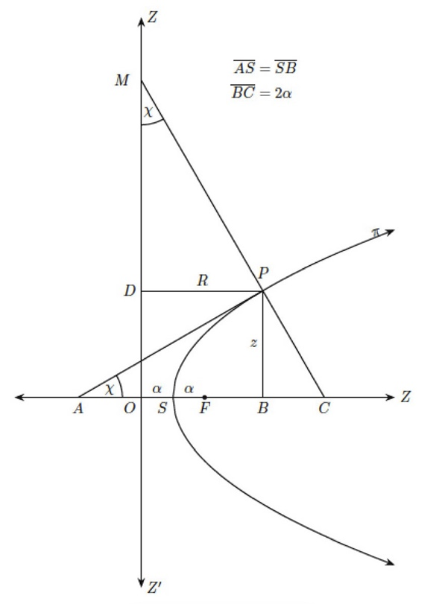

Figure 6 : The Flamm meridian [4] .

Literature now refers to such an object as a "Flamm surface":

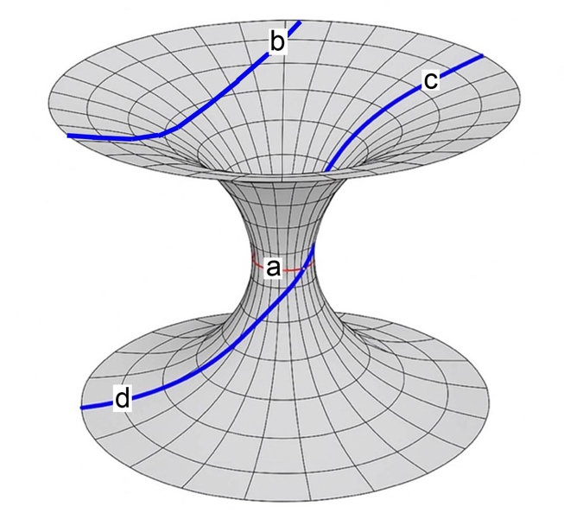

Figure 7 : The Flamm surface.

Can virtual geodesics of such an object be constructed? The corresponding 2D metric is:

(52) ${ds}^{2} = \frac{dr^{2}}{1 - \frac{α}{r}} + r^{2}dφ^{2}$

The length element is :
(53) $ds = \sqrt{ \frac{dr^{2}}{1 - \frac{α}{r}} + r^{2}dφ^{2} }$

Consider radial trajectories $\left( dφ = 0 \right)$. If $r < α$, the element of length ds becomes purely imaginary. We then leave the domain of definition; we are outside the surface. But if we start from the action:
(54) $J = \int{\left( \frac{{\dot{r}}^{2}}{1 - \frac{α}{r}} + r^{2}{\dot{φ}}^{2} \right)ds}$ $\dot{r} = \frac{dr}{ds}$ $\dot{φ} = \frac{dφ}{ds}$

We can then write the Lagrange equations for this function, and we know that if the derivatives are expressed with respect to the length s, which represents the position of the points, they will give us curves that either lie within the domain of definition (r > α) or outside it (0 < r < α). One of the Lagrange equations is:
(55) $\frac{d}{ds}\left( \frac{∂F}{∂\dot{φ} }\right) = \frac{∂F}{∂φ} = 0$

This equation gives us, where h is a constant:
(56) $\dot{φ} = \frac{h}{r^{2}}$

As before, there's no need to write the second one. We can take advantage of the fact that the action yields a unit length:

(57) $1 = \frac{{\dot{r}}^{2}}{1 - \frac{α}{r}} + r^{2}{\dot{φ}}^{2}$

This gives us the differential equation:

$$\left(58\right) \frac{dφ}{dr}=±\frac{h}{r^{2}}\frac{1}{\sqrt{ \left(1 - \frac{∝}{r} \right)\left( 1 - \frac{h^{2}}{r^{2}}\right)}}$$

From this equation we easily obtain the following curves:

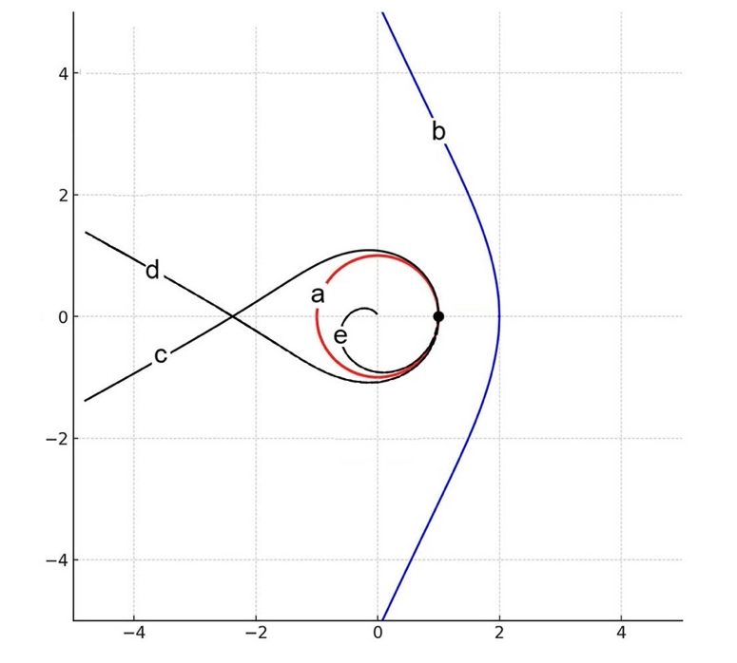
Fig.8 : Real and virtual geodesics.

(b) : ( r > $α$ ; h < $α$ ). (c): ( r > $α$ ; h = $α$ ) . (e) : ( r < $α$ ; h < $α$ )

Circle (a), in red, represents the apparent outline of the Schwarzschild sphere, with radius α. The curve segments (b), (c), and (d), located within the domain of definition, are real geodesics. The curves located inside the circle of radius α are outside the domain of definition and are therefore these "virtual geodesics," real curves along which the length is purely imaginary. The curve segments (c) and (d) that meet on the circle thus correspond to crossing the pass and the transition to the second sheet, as shown in Figure (5). In 1992, S. Chandrasekhar published a work [5] presenting the "standard" interpretation of the Schwarzschild solution.:

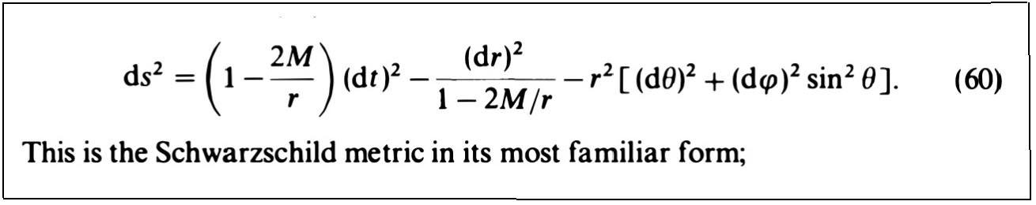

Fig. 9 : The "standard form” of the so-called "Schwarzschild solution".

Here the constant 2M = α. At that time, all cosmologists considered this to correspond to the spherically symmetric stationary solution as presented by Schwarschild in January 1916, and that the variable r was a "radial variable," likely to tend towards zero. It has been shown for decades that the apparent singularity at r = 2M does not cancel the Kretschman scalar, and therefore is not a true singularity but a coordinate singularity, which can be canceled by a simple change of coordinates. Chandrasekhar then adopts the "standard form" of the construction of geodesics:

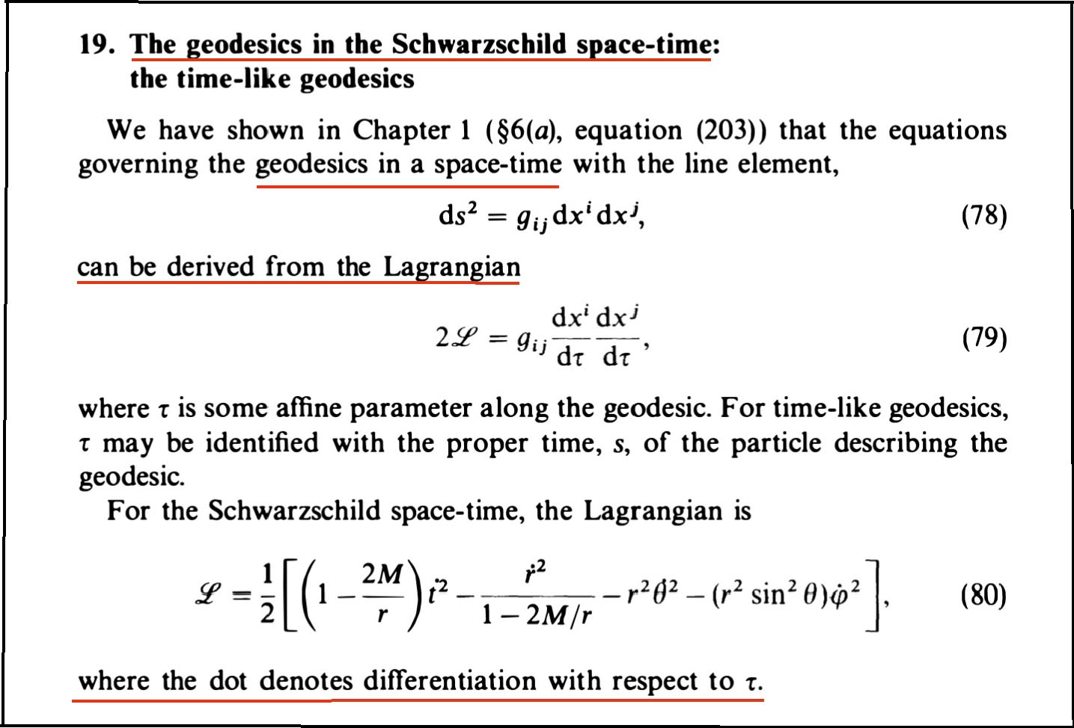

Fig. 10 : The standard method for determining geodesics of Schwarzschild spacetime[5].

We see that he constructs the action not as the length of a curve arc, to be minimized for it to acquire the status of a geodesic, but as an action constructed with a Lagrange function that is no longer constructed from the length element, but from its square. As it is explicitly stated that the derivatives are taken with respect to proper time τ, that is, and this is specified, with respect to s, this technique will indeed give geodesics in the region where they are defined, where the length element is real. But these equations will give, outside this domain of definition, real curves, but endowed with an imaginary length, therefore pseudo-geodesics, without real physical existence. Before presenting the curves obtained by Chandrasekhar, who first made this shift in the choice of the Lagrange function? It was Hilbert in 1916 [3]:

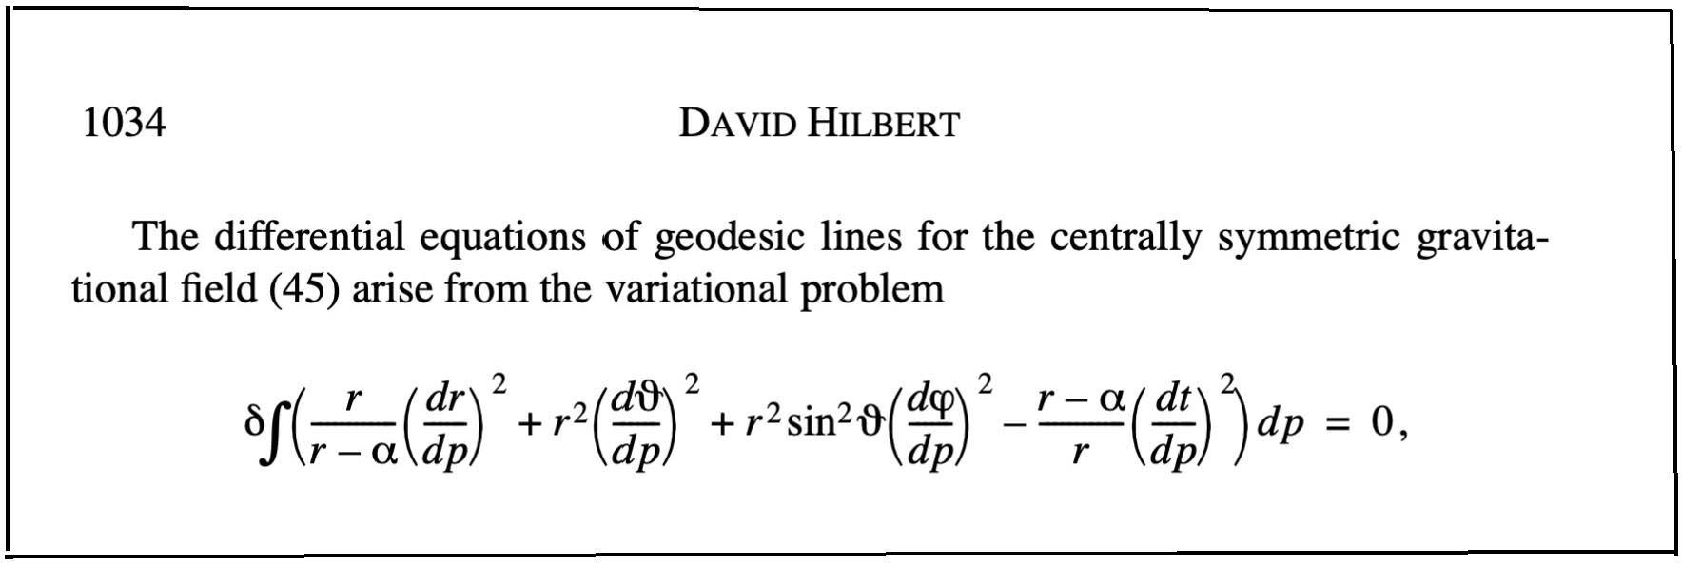
Fig.11 : The action used by Hilbert to obtain the geodesics:

Can we blame him for this, as with the change of variable where, unbeknownst to him, his variable r is in fact the intermediate variable of Schwarzschild's R? Let us remember that this is 1916 and that Schwarzschild, Einstein, and Hilbert knew perfectly well that what would later be called the "Schwarzschild radius," that is, the integration constant α (or 2M), is, for the Sun, 3 kilometers! It was only in the 1970s that Oppenheimer and Snyder [6] proposed using the solution of Schwarzschild's exterior metric to describe an object that J.A. Wheeler [7] would name a "Black Hole." In 1992, Chandrasekhar presented, in his book [5], "The Mathematics of Black Holes." He included numerous images of geodesics. First, there are those which, by grazing the Schwarzschild sphere, reflect the advance of the perihelion, very small for the orbit of Mercury around the Sun (starting point of the construction by Einstein, of his general relativity).

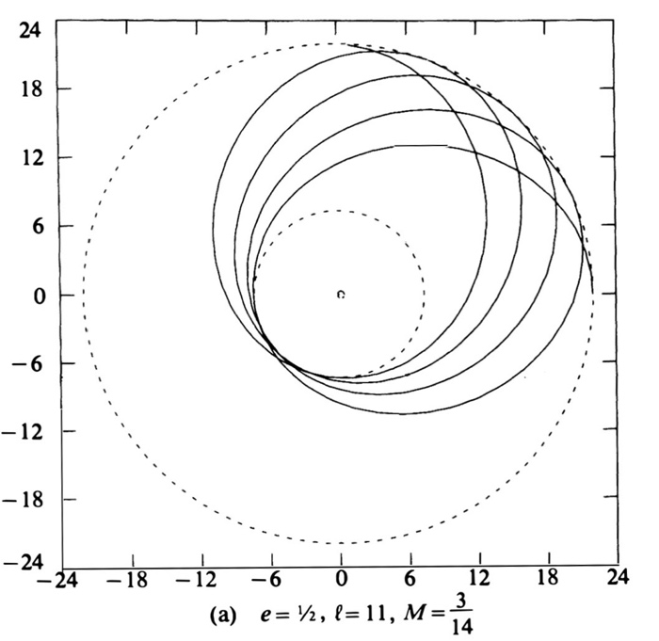

Fig. 12 : Near-elliptical trajectory with advance of perihelion

We then have trajectories that reflect a simple deflection, corresponding for example to the passage of a very fast comet:

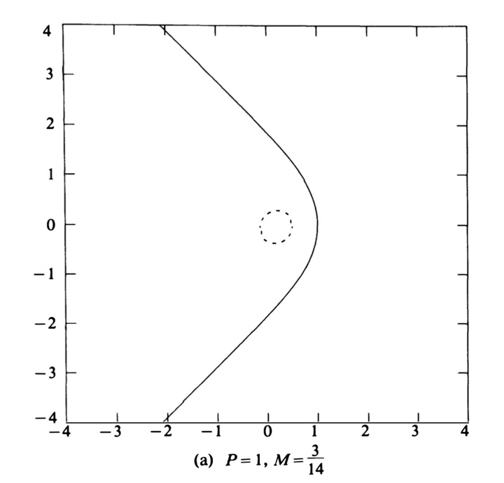

Fig .13 : Simple deflection.

We then have trajectories that intersect, which Chandrasekhar places in the same layer, whereas, tangent to the circle, they reflect a change of layer on the Flamm surface

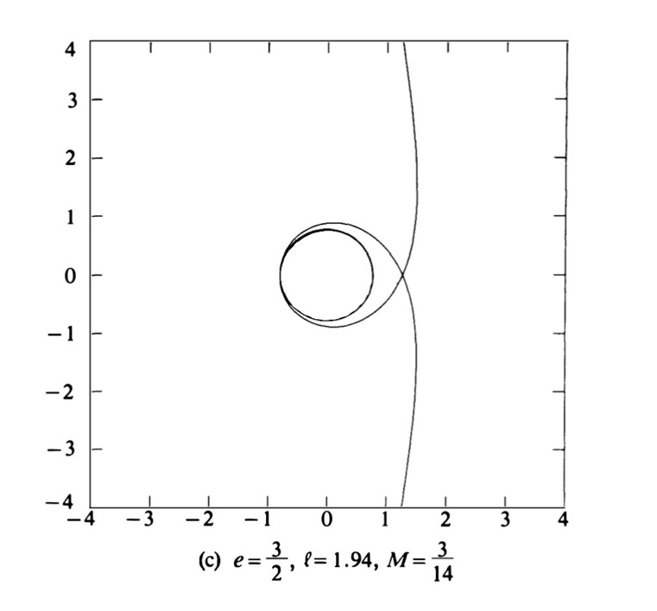

Fig.14 : Gamma letter projection of a geodesic.

Finally, there are curves that spiral indefinitely towards what Chandrasekhar and all cosmologists consider to be "the central singularity":

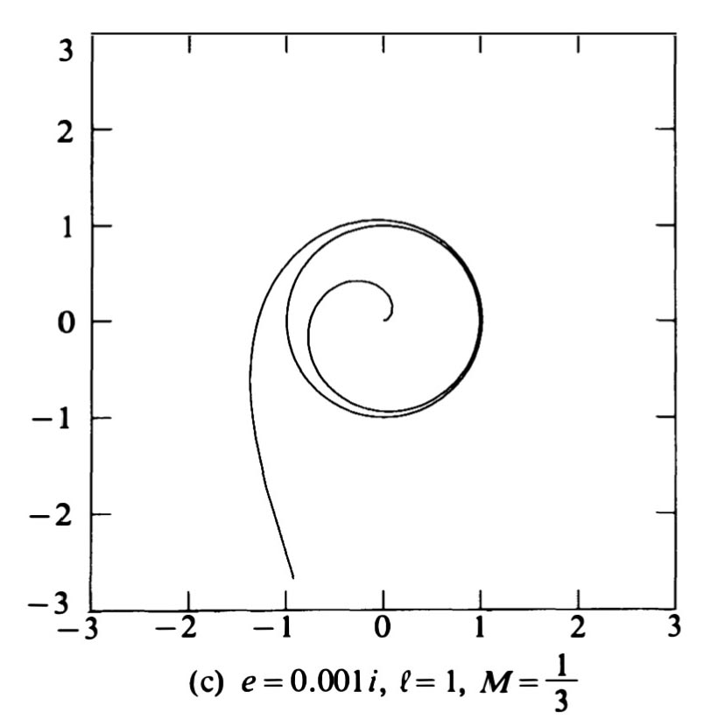

Fig.15 : Chandrasekhar: trajectory of a witness mass plunging
towards the "central singularity".

According to what has just been shown above, the portion of the curve inside the circle, endowed with a purely imaginary length, is merely an artifact resulting from the choice of the Lagrange function. It is therefore outside the solution hypersurface. But countless articles have been published concerning this region, as well as theorems have been established concerning this central singularity which arises from the chimerical interpretation that has been made of this Schwarzschild solution [1].

References. :
[1] K. Schwarzschild : Über das Gravitationsfeld Messenpunktes nach der Einsteinschen Theorie. Sit. Deut. Akad. Wiss. 1916
English translation by S.Antoci and A.Loinger. On the gravitational field of a mass point according to Einstein theory. arXiv :physics/9912033v1 [physics.hist-ph] 16 dec 1999.
[2] L.S.Abrams : Black Hole : the Legacy of Hilbert’s Error. Can. Jr. Phys. 67 , 9191 ( 1989es tv13 feb 2001.
[3] D.Hilbert. Die Grundlagen der Physik (Esrte Mitteilung). Nachrochten von der Gesellschaft der Wissenschaften zu Göttingen. Mathematisch-physikalische Klasse. (1916). English translation. The foundations of Physics (second communication)
Boston Series in Philosophy and Science. Copyright Springer, Vol.250 2007
https://link.springer.com/chapter/10.1007%2F978-1-4020-4000-9_45
[4] Ludwig Flamm. Beiträge zur Einsteinschen Gravitationstheorie, Physikalische Zestschrift XVII (1916) pp. 448-454.
[5] S.Chandrasekhar :The Mathematical Theory of Black Holes. Okford University Press 1992
[6] J.R.Oppenheimer and H.Snyder : On Continued Gravitational Contraction. Phys. Rev. Vol. 56 pp 455-459 sept 1939
[7] C.W.Misner, K.S.Thorne, J.A.Wheeler : Gravitation. Princeton University Press. 2017.

